ParkinsonSAT

Interface Control Document
USNA Small Satellite Program

Microdosimeter Instrument

1/C Reid Smythe
1/C Max Mayer



United States Naval Academy
Annapolis, Maryland

Reviewed by:
 | MIDN Mayer, Psat Design Team |  | Date
Reviewed by:
 | MIDN Smythe, Psat Design Team |  | Date
Reviewed by:
 | Bob Bruninga, Psat Principle Investigator |  | Date
Reviewed by:
 | Professor Pisacane, MiDN Principle Investigator |  | Date

Revision Log

Revision | Description | Author | Date | Approval
1 | Typos and Corrections | 1/C Mayer | 12APR
2
3
4
5
6
7
8
9
10

Table of contents

Signature Page Cover Page
Revision Log ii
Table of contents iii
List of Figures iv
List of Tables iv
List of Drawings iv
Acronyms iv
1 Introduction 1
1.1 Scope 1
1.2 Experimental Description 1
2 Administration 2
2.1 Configuration Management 2
2.2 Precedence of Documents 2
3 Interface Definitions and Description 3
3.1 Units 3
3.2 Microdosimeter Instrument 3
3.2.1 Mechanical Interfaces 3
3.2.2 Mounting and Alignment 3
3.2.3 Thermal Interfaces 4
3.2.4 Electrical Connections 4
3.2.5 Mechanical Interface Drawings 4
3.3 Electrical Power 5
3.3.1 Voltage 5
3.3.2 Current 5
3.3.3 Power Quality 5
3.3.4 Loads 5
3.3.5 Grounding 5
3.3.6 Power Draw Profiles 5
3.4 Discrete Electrical Signals 6
3.4.1 Discrete Analog Inputs 6
3.4.2 Discrete Analog Outputs 6
3.4.3 Discrete Digital Inputs 6
3.4.4 Discrete Digital Outputs 6
3.5 Serial Digital Communications 6
3.5.1 Input Signals from PSat to MiDn 6
3.5.2 Output Signals from MiDn to PSat 7
3.6 Software Interfaces 7
References 8

List of Figures
Figure 1. Parkinson Satellite 1
Figure 2. PSat Block Diagram 1
Figure 3. ParkinsonSAT 2
Figure 4. MiDn Sensor 3
Figure 5. RD15 Male Connector 9

List of Tables
None yet

List of Drawings
None yet

Acronyms
$\text{APRS}$ Automatic Packet Reporting System
$\text{AX}\text{25}$ Communications Packet Protocol
$\text{CPU}$ Computer Processing Unit
$\text{EPS}$ Electrical Power System
$\text{HDLC}$ High-level Data Link Control
$\text{ISS}$ International Space Station
MiDn………………………... Microdosimeter Instrument
$\text{NASA}$ National Aeronautics and Space Administration
$\text{NRL}$ Naval Research Laboratory
PIC ………………………… Programmable Interface Computer
$\text{PSAT}$ Parkinsonsat
UART ………………………. Universal Asynchronous Receiver/Transmitters
$\text{USNA}$ United States Naval Academy

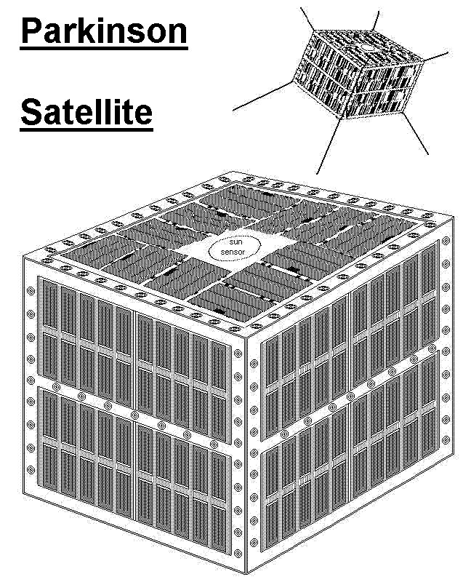
Introduction

Scope
This document shall cover specifications and areas of responsibility relevant to the interface between the Micro Dosemeter (MIDN) and ParkinsonSAT. Both projects are under design by the US Naval Academy Small Satelltie Program.

The primary mission of PSAT (shown in Figure 1) is to be a satellite communications transponder for data exfoliation of data from remote environmental sensors or other data sources and to support other payloads and experiments such as MIDN.
Figure 1. Parkinson Satellite

ParkinsonSAT is organized around two dual redundant Communications Command and Control systems called TNC’s (Terminal Node Controllers) that provide the basic communications functions as well as telemetry and command/ control of the various payloads as can be seen below in Figure 2. Note that the CPU has dual redundant communications paths via each of the TNC’s to the ground through the dual radio systems. The CPU then communicates with each of the additional payloads via a common 9600 baud serial port.

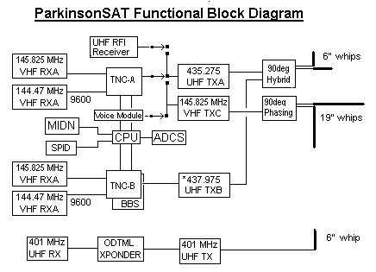
Figure 2. PSat Block Diagram

The structure of ParkinsonSAT, is designed for optimal access to each system during integration, and for optimum heat dissipation while on orbit. As shown in Figure 3, the structure consists of four side panels that support most of the payload. These side panels are thermally connected to four internal bulkheads that serve not only as sidewall stiffeners, but also serve as thermal paths to eaualize temperatures throughout the spacecraft. The central rectangular area will house the Attitude Dynamics and Control System (ADCS) .


Figure 3. ParkinsonSAT

Some of the other payloads and missions that PSAT will support include the following:

  - Ocean Data Telemetry Microsat Link (ODTML) transponder for DOD related ocean -buoys and data sources

  - AMSAT transponders operating in the Amateur Satellite Service for educational and academic use by students and universities

  - MiDn – A joint ONR/ Naval Academy Micro Dosimeter for radiation measurements

  - UHF-RFI – A joint NRL/Naval Academy UHF Interference Mitigation Receiver

  - SPID – A joint ONR/USNA Small Particle Impact Detector

MiDn Experimental Description
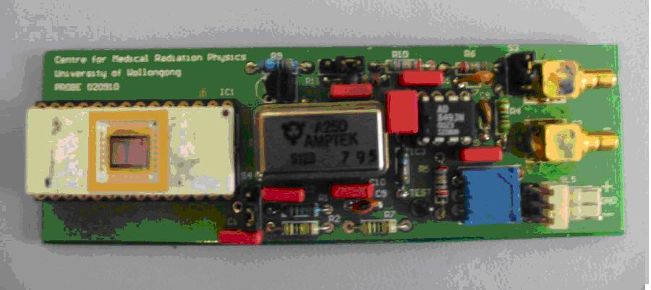
Figure 4. MiDn Sensor

The Microdosimeter Instrument or MiDn is one of ParkinsonSAT’s payloads under development at USNA’s Small Satellite Program. It is a solid-state system being designed and constructed to measure microdosimetric spectra to determine radiation quality factors for space environments. Radiation is a critical threat to the health of astronauts and to the success of missions in low-Earth orbit and space exploration. Therefore the MiDn payload will study the effects of radiation in space. The actual sensor is seen in Figure 4.

Administration

Configuration Management
This document shall be updated at the mutual agreement of the MiDn Principal Investigator, Prof V. Pisacane and the ParkinsonSAT Principal Investigator, CDR Bruninga, USN, (ret). Changes may be suggested, negotiated and assented to by email. The latest mutually agreed upon electronic version of this document shall have the same force and standing as a signed paper document. The draft copy of this document can be found on the ParkinsonSAT web page:
http://www.ew.usna.edu/~bruninga/psat.html

Precedence of Documents
This document has precedence over any and all other written, verbal or electronic statements addressing interface issues.

Interface Definitions and Description

Units
Both English and metric units shall be used in all cases where both are defined.

Microdosimeter Instrument

Mechanical Interfaces

Physical Properties

Dimensions
MiDn will be placed in a compartment with dimensions of 7.375 in x 4.25 in x 10.5 in. These bounding dimensions must contain all cables, connectors and mounting hardware.

Materials
All materials must be space rated. Aluminum shall be 6061 except where noted.

Mass
The mass will not exceed 2 kg.

Surface Treatments
All aluminum surfaces shall be iridited or anodized. Black anodizing is recommended for maximum thermal balance between all systems.

Mounting and Alignment

Mounting Specifications
MiDn will be located in a 7.375 in X 4.25 in X 10.5 in. sidewall compartment within PSAT. This compartment is designed so that two of the sides are the external surfaces of the satellite while the other two sides are the internal thermal bulkhead. Preferably, a majority of the mass of MiDn should be mounted towards the external portion of the spacecraft for best attitude dynamics. Mounting hardware will consist of #6-32 or #4-40 screws.

Alignment Specifications
Although there are no specific alignment specifications, it should be noted that the Sun facing attitude of the –Z Psat face will result in a significant temperature gradient from the –Z to the +Z faces.

Thermal Interfaces

Temperature Limits
Space frame mounting surfaces will range from -10 to +40 degrees Celsius operational and -40 and +60 degrees C storage and extremes. During stable attitude control the average spacecraft temperature should range between 0 deg C and 30 deg C depending on orbit inclination, precession and eclipse periods.

Temperature Monitoring Components
Independent of any MiDn requirements, PSAT will have a thermistor located on the most heat sensitive or heat generating component of MiDn to monitor the temperature of the payload. The temperature of this sensor will be included in the routine housekeeping telemetry downlink from Psat.

Thermal Control Components
Heat generated within the spacecraft due to MiDn operations will be transferred throughout the structure via internal bulkheads and dissipated into cold space. There is no power available for heaters. Thermal control must be via passive techniques only.

Electrical Connections

Connector Hardware Specifications
Connectors will all consist of crimp pin “DB” type connectors.

Ground Straps
Standard internal payload grounding policies will apply.

Connector Pin-outs
+8 V Bus-A – Power from the A system
+8 V Bus-B – Power from the B system
MIDN TXD - Serial Port from MIDN to Psat
MIDN RXD – Serial Port from Psat to MIDN
MIDN GND – Signal Ground
Status bit1 – digital discrete TBD
Status bit 2 – digital discrete TBD
Thermister+
Thermister-
8 V Return A
8 V Return B

Bonding Specifications
Since MIDN is housed internally to Psat, no additional safety bounding or grounding is required other than the metail conductive mounting hardware. All ground returns will be via dual pins in the interface connector to the single point grounds in the communications systems.

Intra-payload Harness
MIDN’s primary interface is with th ePsat communications transponders and no other intra-payload harnesses are required.

Mechanical Interface Drawings

TBD

Electrical Power

Voltage
Both bus A and B will be unregulated 8 volts. This will be distributed using a #20 AWG wire.

Current
MiDn currently requests 275 mA. This represents 27.5% of the total available power budget design for PSAT. Other power saving modes of operation with a lower duty cycle must be investigated. Both sides bus A and B can provide a total of 275 mA average current to MiDn. The peak instantaneous current can be up to 1 amps. The fuse will be rated at 2 amps.

Power Quality
MiDn is providing clean power for itself. PSat will provide power of sufficient quality to safely charge its batteries. The unregulated 8 volt bus is driven by six NiCd cells and will vary between 7.2 and 8.4 volts operationally. A low voltage cut out will occur at 6 volts. During battery charging, bus voltages as high as 8.8 volts can occur.

Loads
MiDn’s starting load is 525 mA, operating load is 275 mA. PSat power system will providing charging power availability for MiDn’s batteries.

Grounding
Standard internal load grounding policies will apply.

Power Draw Profiles

Nominal Power
275 mA @ 7 volts (as noted above, this is over-budget).

Peak Power
525 mA @ 7 volts for startup (<100 ms)

Standby Power
0 mA

Survival Power
0 mA

Duty Cycles
100%/0%

Discrete Electrical Signals: The thermistor is part #KC00GE-ND

Discrete Analog Inputs
None

Discrete Analog Outputs
Thermistor +
Thermistor -

Discrete Digital Inputs
Two discretes, TBD

Discrete Digital Outputs
Two discretes. TBD

Serial Digital Communications
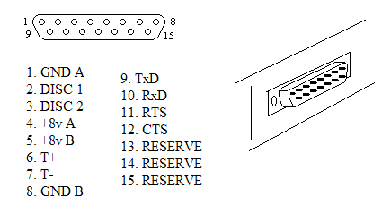
Figure 5. DB15 Male Connector

MiDn RxD. RS232 or RS422 from PSat to MiDn (9600 bd)
MiDn TxD. RS232 or RS422 data from MiDn to PSat (9600 bd)
RTS – Request to send
CTS – Clear to send

Input Signals from PSat to MiDn

Signals Characteristics
RS232, RS422, or TTL

Command Protocols
Designed via PIC Microcontroller with double UART configuration

Data Input Protocols
Same as 3.5.1.2

Command Upload Protocols
Same as 3.5.1.2

Output Signals from MiDn to PSat

Signal Characteristics
RS232 or RS422

Telemetry Output Protocols
If MiDn system wants to include up to five routine housekeeping telemetry values in the routine Psat downlink telemetry stream, the following format will be used. The MiDn process first has to check for a not-busy on the CTS handshaking line. If clear, then MiDn must assert the RTS line and then pause 100 ms before sending telemetry in the following format:

}MIDN>APxxxx:T#SSS,111,222,333,444,555,xxxxxxxx.

There will be several telemetry outputs from MIDN. A plus and minus temperature will be required using an AWG #24 wire. One status bit will be placed on PSAT. There will be a ground.

Data Output Protocols

If there are any other specialized data formats required of MiDn, then the following additional formats may be used.

}MIDN>APxxxx:{SX…….where x can be…??

The transmit data will occur at 9600 Baud. The experiment serial data bus will contain packetized printable ASCII data to and from all onboard experiments, to and from all user ground stations and any other serial data on the channel. The MiDn processor must ignore all such data except for the packets specifically addressed to it. There is no software flow control.

Software Interfaces
The MiDn instrument will collect and store data. It will then transmit the stored data to the groundstation via PSat communication systems.

The ParkinsonSAT payload serial data bus will contain packetized printable ASCII data to and from all onboard experiments, and also to and from all user ground stations and any other serial data on the channel. The individual payload processors (SPID) must ignore all such data except for the packets specifically addressed to it. All data on the Serial Data Bus will be in the following standard AX.25 format:

SOURCE>DEST,PATH,PATH:xxxxxxxxxxxxxxxxxx….

Where SOURCE is a 3 to 9 byte variable length field indicating the originator of the packet. Only the uppercase and numeric characters are used in the first 6 bytes and the final 3 may contain a one or two byte numeric field (“-1” to “-15”).

Where DEST is a 3 to 6 byte destination field. This field has the same character restrictions as the source. Since most data on the payload bus is transmitted in broadcast manner, the destination field is often used to indicate a version number or other identifier.

Where PATH is a series of from none to seven comma separated fields indicating the RF path for the data. These fields are also limited to the character restrictions of the source field. Typically if a packet is relayed by a ground station or another satellite, the callsign of that station will be included here.

References
Snead, William. “MiDn on ParkinsonSat PDR Write-up.” 06DEC06.

