ParkinsonSAT Electrical Power System

Introduction

The electrical power system on ParkinsonSAT distributes power from the solar cells and batteries to the various loads at the correct via a dual redundant A/B bus system. The dual bus system, controls, and resettable fuses ensure that faults in the loads will not bring the entire system down. The electrical power system also provides for proper battery charge conditioning.

Solar Power System

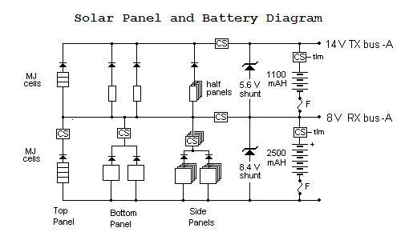
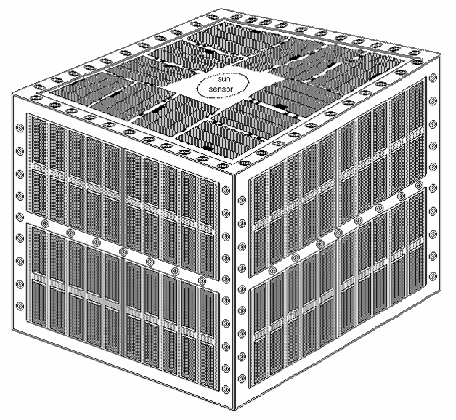
The solar panels on ParkinsonSAT provide the necessary power to operate the spacecraft and to charge the batteries. Figure 1 shows the arrangement of the solar panels on each of the four sides as well as the top of the spacecraft. The bottom is similar to the sides. Figure 2 shows a schematic of how each side of the system will be wired together. Each side face will have separate power circuits for the A and B systems of the spacecraft. Each A/B system will have two full panels wired in parallel to generate the proper voltage for the 8v bus, an additional half panel is used to generate the rest of the voltage necessary to create the 14v bus. The bottom face will also have A and B systems consisting of two full solar panels in parallel providing power to the 8v bus and those will be wired in series with two half panels, wired in parallel, to provide the additional voltage for the 14v bus. The top face will use the high-cost, high efficiency solar cells. It will have, similarly, A and B strings consisting of 4 solar cells which will be wired in series for the 8v bus and 3 solar cells to provide the added voltage for the 14v bus.
Figure 1: Physical Solar Panel Diagram

Figure 2: Side A EPS (B is similar)

Battery System

The battery system on ParkinsonSAT is composed of two banks, an A and B set, each divided into two strings of cells. The separate banks allow for redundant 8 and 14 volt busses to distribute power to the loads. The 8v buses consist of 6 cells wired in series. The 14v buses use an additional 4 cells.

Charging of the battery system from the solar panels is regulated via shunt regulators to prevent overcharging. Fuses are placed in the ground end of the batteries to prevent a short in a cell to the battery casing from generating a catastrophic hazard to both the battery and the spacecraft.

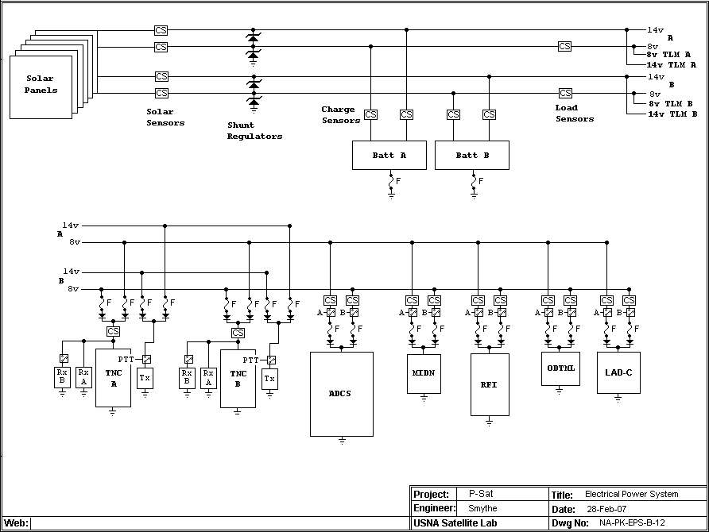
Figure 3: ParkingsonSAT EPS Block Diagram

Loads

 | Current (mA) | Duty Cycle |  |  | Avg (mA)
 | Current (mA) | H | L | S | H | L | S
VHF FM TX1 | 500 | 27% | 6% | 2% | 133 | 29 | 8
VHF FM TX2 | 500 | 27% | 6% | 2% | 133 | 29 | 8
VHF FM RX1 | 30 | 100% | 100% | 100% | 30 | 30 | 30
VHF FM RX2 | 30 | 100% | 100% | 100% | 30 | 30 | 30
VHF FM RX3 | 30 | 100% | 100% | 100% | 30 | 30 | 30
VHF FM RX4 | 30 | 100% | 100% | 100% | 30 | 30 | 30
TNC1 | 40 | 100% | 100% | 100% | 40 | 40 | 40
TNC2 | 40 | 100% | 100% | 100% | 40 | 40 | 40
10% Reserve |  |  |  |  | 47 | 26 | 22
Avg (mA) |  |  |  |  | 513 | 284 | 238
MiDn | 275 | 100% | 0% | 0% | 275 | 0 | 0
ODTML | 625 | 100% | 16% | 3% | 625 | 100 | 20
RFI | 50 | 100% | 0% | 0% | 50 | 0 | 0
ADCS | 500 | 20% | 10% | 5% | 100 | 50 | 25
10% Reserve (payloads) |  |  |  |  | 105 | 15 | 5
Avg (mA) |  |  |  |  | 1668 | 449 | 288

Table 1 gives lists the power requirements for the various spacecraft systems. The power distribution block diagram is shown in figure 3.
 | Current (mA) | Duty Cycle |  |  | Avg (mA)
 | Current (mA) | H | L | S | H | L | S
VHF FM TX1 | 500 | 27% | 6% | 2% | 133 | 29 | 8
VHF FM TX2 | 500 | 27% | 6% | 2% | 133 | 29 | 8
VHF FM RX1 | 30 | 100% | 100% | 100% | 30 | 30 | 30
VHF FM RX2 | 30 | 100% | 100% | 100% | 30 | 30 | 30
VHF FM RX3 | 30 | 100% | 100% | 100% | 30 | 30 | 30
VHF FM RX4 | 30 | 100% | 100% | 100% | 30 | 30 | 30
TNC1 | 40 | 100% | 100% | 100% | 40 | 40 | 40
TNC2 | 40 | 100% | 100% | 100% | 40 | 40 | 40
10% Reserve |  |  |  |  | 47 | 26 | 22
Avg (mA) |  |  |  |  | 513 | 284 | 238
MiDn | 275 | 100% | 0% | 0% | 275 | 0 | 0
ODTML | 625 | 100% | 16% | 3% | 625 | 100 | 20
RFI | 50 | 100% | 0% | 0% | 50 | 0 | 0
ADCS | 500 | 20% | 10% | 5% | 100 | 50 | 25
10% Reserve (payloads) |  |  |  |  | 105 | 15 | 5
Avg (mA) |  |  |  |  | 1668 | 449 | 288

All loads with the exception of the transmitters operate from the 8v buses of both system A and system B. Schottky diodes with a .5v drop provide isolation between the dual redundant systems. Relays control the power availability to each load. The primary receivers, TNC modems and CPU system are always powered. Resettable fuses in series with each load, located electrically between the loads and the buses, prevent a fault in one load affecting the rest of the distribution system. The two transmitters are powered from the 14v busses on both the A and B systems, with similar fuses and diodes to protect the system integrity. The transmitters operate in a low duty cycle burst mode and are only powered when keyed by the TNCs.

All loads can be powered from one side of the system alone; it is not necessary for both sides of the electrical power system to be operable for the loads to receive power. The batteries are designed to operate 35 minutes in eclipse while running under full load and remaining above a 20% depth of discharge.

To determine the average system load, duty cycles for each subsystem must be determined. Determining the transmitter duty cycle begins with estimating the number of minutes per day the satellite is expected to be transmitting data to users. Table 2 was used to estimate the user data load. This is then combined with the other transmission packets (telemetry, beacons and other system data) to determine the length of time the transmitter will be transmitting in orbit. For each transmission type, a minimum (standby), typical, and maximum value are tabulated in table 3.
Duty cycles for all other loads are estimated, and average currents can then be calculated to give an average required power, shown in table 1.

Country | Pass/Day | Transponder Load Density | Weighted PPD | Min/Pass | Total Minutes
W-USA | 6 | 1 | 6 | 20 | 120
E-USA | 6 | 1 | 6 | 20 | 120
W-EU | 6 | 1 | 6 | 15 | 90
E-EU | 6 | 0.7 | 4 | 15 | 60
NZ | 6 | 0.5 | 3 | 15 | 45
Japan | 6 | 0.5 | 3 | 10 | 30
S. America | 6 | 0.3 | 2 | 10 | 20
S. Africa | 6 | 0.1 | 1 | 10 | 10
Hawaii | 6 | 0.1 | 1 | 10 | 10
Total |  |  |  |  | 505
Min/Day |  |  |  |  | 1440
Demand Load |  |  |  |  | 35%

Data | Pkts/Min |  |  | Usage | Weighted Pkts/Min
Data | H | L | S | Usage | H | L | S
Telemtry | 6 | 1 | 1 | 100% | 6 | 1 | 1
Beacons | 1 | 0.2 | 0 | 100% | 1 | 0.2 | 0
Bulletins | 2 | 0.5 | 0 | 100% | 2 | 0.5 | 0
Users | 20 | 5 | 0 | 35% | 7 | 1.75 | 0
Total |  |  |  |  | 16 | 3.45 | 1
Duty Cycle |  |  |  |  | 27% | 6% | 2%

 | Current (mA) | Duty Cycle |  |  | Avg (mA)
 | Current (mA) | H | L | S | H | L | S
VHF FM TX1 | 500 | 27% | 6% | 2% | 133 | 29 | 8
VHF FM TX2 | 500 | 27% | 6% | 2% | 133 | 29 | 8
VHF FM RX1 | 30 | 100% | 100% | 100% | 30 | 30 | 30
VHF FM RX2 | 30 | 100% | 100% | 100% | 30 | 30 | 30
VHF FM RX3 | 30 | 100% | 100% | 100% | 30 | 30 | 30
VHF FM RX4 | 30 | 100% | 100% | 100% | 30 | 30 | 30
TNC1 | 40 | 100% | 100% | 100% | 40 | 40 | 40
TNC2 | 40 | 100% | 100% | 100% | 40 | 40 | 40
10% Reserve |  |  |  |  | 47 | 26 | 22
Avg (mA) |  |  |  |  | 513 | 284 | 238
MiDn | 275 | 100% | 0% | 0% | 275 | 0 | 0
ODTML | 625 | 100% | 16% | 3% | 625 | 100 | 20
RFI | 50 | 100% | 0% | 0% | 50 | 0 | 0
ADCS | 500 | 20% | 10% | 5% | 100 | 50 | 25
10% Reserve (payloads) |  |  |  |  | 105 | 15 | 5
Avg (mA) |  |  |  |  | 1668 | 449 | 288

Eclipse and Available Power

Based on the design solar cell configuration, there will be an average of 10W per system of available power. This gives 1.25A at 8V for each system for a total of 2.5A available from both sides. Assuming an altitude of 500km with a resulting eclipse time of 36 minutes, table 4 summarizes the current available to charge the battery when the satellite is in daylight compared to various loadings. In order to achieve a charging current while in daylight, eclipse load must be reduced to less than 1200 mA.

Isa (mA) | Ie (mA) | Id (mA) | Id-Ie (mA)
2500 | 250 | 1926 | 1676
2500 | 500 | 1726 | 1226
2500 | 750 | 1527 | 777
2500 | 1000 | 1327 | 327
2500 | 1250 | 1128 | -122
2500 | 1500 | 928 | -572
2500 | 1750 | 729 | -1021
2500 | 1668 | 794 | -874 | H
2500 | 449 | 1767 | 1318 | L
2500 | 288 | 1895 | 1607 | S

