Antenna Design Review

The current design for P-Sat calls for four separate RF systems. A VHF (146 MHz) up and downlink for the TNC, an UHF (436 MHz) up and downlink for the TNC, an Ocean Data Telemetry Measuring Link (ODTML) system (406 MHz) and a Radio Frequency Interference (RFI) transponder (300 MHz).

For these antennas a split dipole system was chosen with 90 degree phasing in between each monopole. The monopoles will be placed at 45 degree angles from the plane of each side on opposite sides of the panel. A basic diagram of the antenna arrangement is shown below.
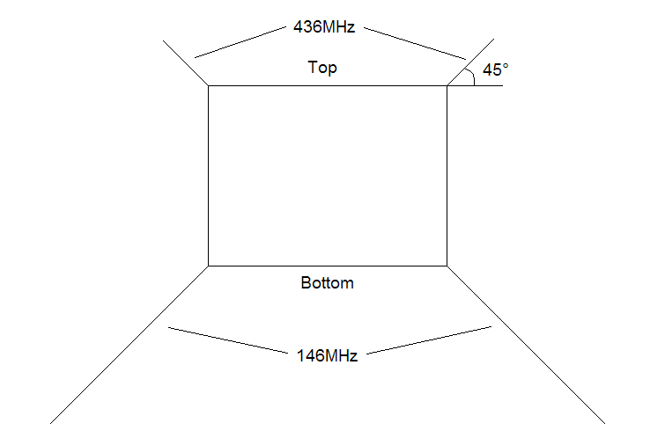
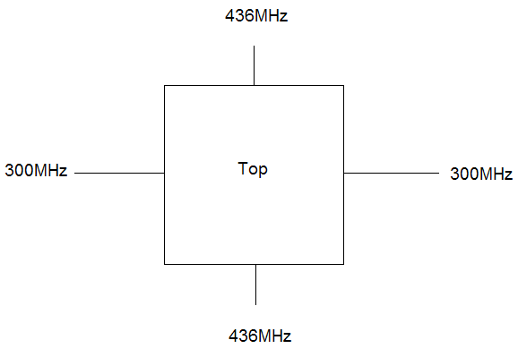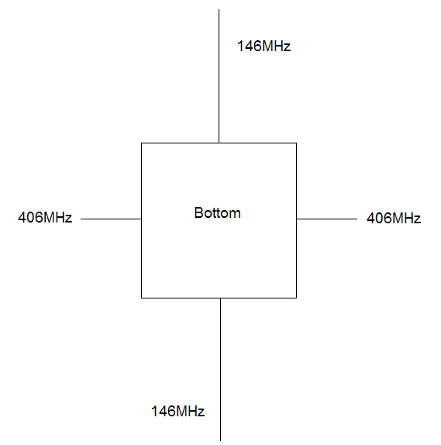

Once an initial design was determined, a model of P-sat was created in EZNEC. The model has the same dimensions as P-sat (10-7/8 in. by 12-3/4 in.). It was created with 6 wires of 5 segments each to give a total of 300 segments. The model without the antennas is shown below.

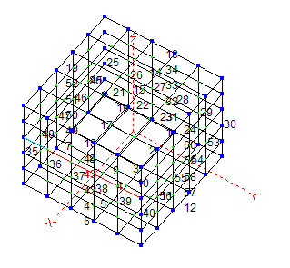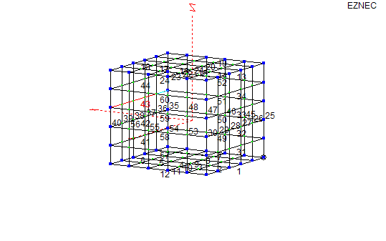

Next the estimated lengths were calculated assuming a ¼ wave dipole for each frequency. These antennas were then placed on the model per the initial design. The model with the antennas is shown below.
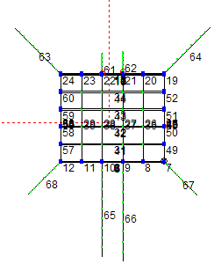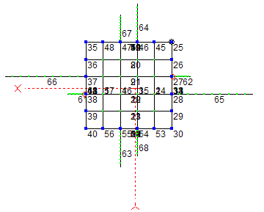
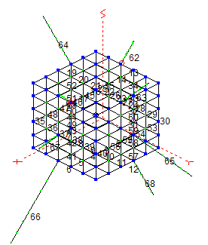

Once the antennas were added, the length and diameter for each antenna was adjusted to minimize SWR for each antenna. Finally, Far-Field plots were created to determine the gain performance. The information for each antenna is shown below

436 MHz

Antenna 1:
Length: 7.05 in Dia: .85 in
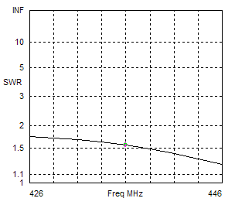
SWR at 436 MHz: 1.56

Antenna 2:
Length: 6.91 in Dia: .85 in
SWR at 436 MHz: 1.85
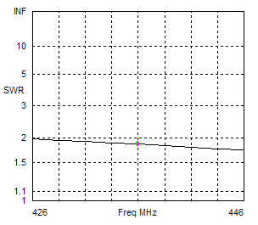
FF Plots:
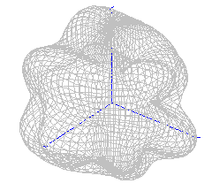3D
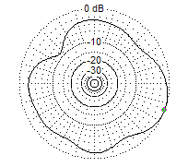Az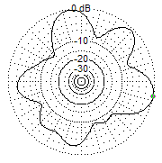El

Peak gain for the Elevation was 4.72 dB with a minimum gain of -6.69 dB. Peak gain for the Azimuth was 4.41 dB with a minimum gain of -4.41 dB.

300 MHz

Antenna 1
Length: 8.2 in Dia: .5 in
SWR at 300 MHz: 1.056
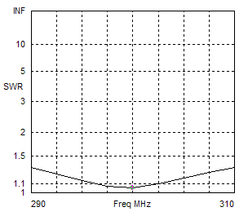
Antenna 2
Length: 7.48 in Dia: .2
SWR at 300 MHz: 1.082
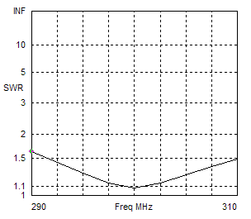
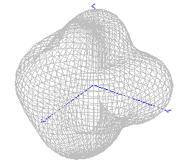3D

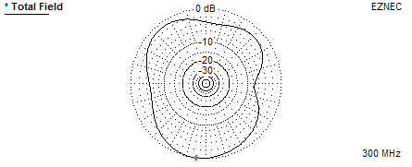Az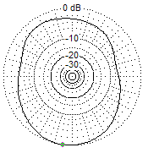El

Peak gain for the Elevation was 3.02 dB with a minimum gain of -4.27 dB. Peak gain for the Azimuth was 3.72 dB with a minimum gain of –3.84 dB.

145 MHz

Antenna 1
Length: 17.67 in Dia: .8 in
SWR at 145 MHz: 1.68
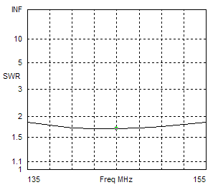

Antenna 2
Length: 19.09 in Dia: .1 in
SWR at 145 MHz: 1.47
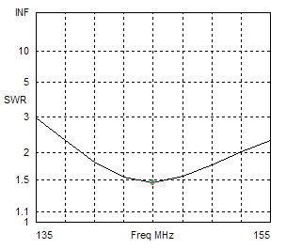

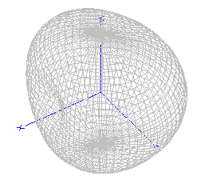3D

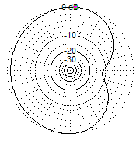Az 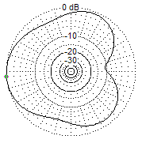El

Peak gain for the Elevation was 0.87 dB with a minimum gain of -10 dB. Peak gain for the Azimuth was 1.82 dB with a minimum gain of –9.76 dB.

406 MHz

Antenna 1
Length: 6.43 in Dia: .1
SWR at 406 MHz: 1.11
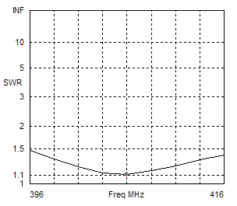

Antenna 2
Length: 5.86 in Dia: .1
SWR at 406 MHz: 1.21
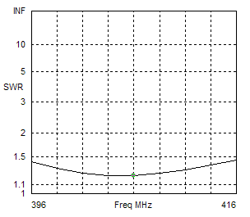
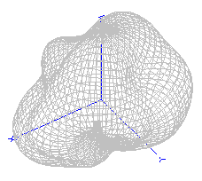3D
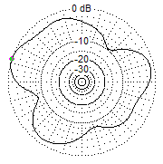Az 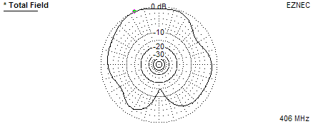El

Peak gain for the Elevation was 2.61 dB with a minimum gain of -11.97 dB. Peak gain for the Azimuth was 2.46 dB with a minimum gain of -7.06 dB.

