Cave Link Radio Communications Test Plan
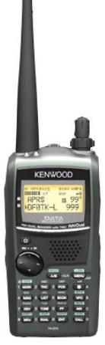
1 March 2013
Rev c

APRS Engineering LLC and
FCC Licensed Communications Volunteers

Principal Investigator: Robert (Bob) Bruninga, US Naval Academy, Annapolis Maryland. 410-293-6417 – bruninga@usna.edu. Other test volunteers:

WB4APR Bob - Team Leader
KG4LVA John - IGate Operator- topside
KY4JME Josh - Snowball Room operator (Igate and HF)
KG4CSQ Ralph - Caver and topside HF tester
KJ4AJP Roger - Everything else

Date: Saturday/Sunday 2-3 March 2013
Meet: 0830 AM Saturday. Pavilion north of visitors center.
I might get there by 11 PM Fri nite @ hotel, so watch me on APRS
Talkin: 444.925+ Primary – Cave City
444.850+114 PL – Munfordville
146.94- secondary – Cave City

Weather: The 5 day forecast is for cold. High temperature of 32F. Not very conducive to much topside hand portable HF and VHF and UHF testing.

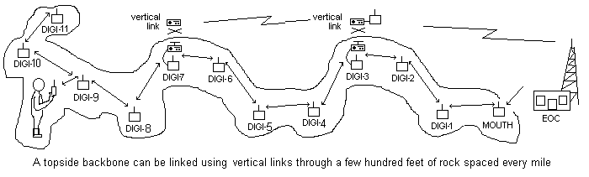
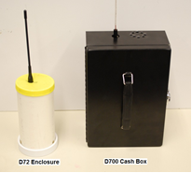
Abstract: The purpose of the test is to test the viability of using APRS VHF/UHF walkie-talkies in caves for distance communications along passages by taking advantage of the radio’s internal hop-by-hop linking capability for digital text messaging. Links up to 7 or 14 hops long are possible which can extend the usual very limited 100’ to 500’ radio range by an order of magnitude or over a mile depending on a variety of factors to be tested.

1. Digipeaters: Either the TH-D72 walkie-talkie or a boxed D700/D710 as shown here will be used for each relay location. See http://aprs.org/cave-link.html

2. Internet Operator: (John, KG4LVA) Sets up an APRS system and IGate topside in a WiFi area in the Hotel or an NPS workroom where the test can be monitored. The IGate operator is the topside point of contact with NPS. For example, NPS personnel can view the progress of the test, and positions of the participants on any PC via the internet on the http://aprs.fi site. His APRS RF system has to be able to hear the topside digi over by the Elevator about 1.6 miles away. He carries a D7 so we can communicate with him wherever he is.

3. CaveCamp Team: Josh, KY4JME sets up a topside digipeater near the Elevator to link down to the first Cave digi and an APRS operating position in the Snowball room. Hopefully the vertical link is no more than placing one radio near the vertical wiring drops both above and below ground and letting stray-coupling or the elevator shaft achieve the 240’ vertical distance. This area will also be base camp for all other NSS volunteer activities that day. They confirm both RF and WiFi connectivity with the Internet Operator topside. An HF radio is also available.

4. Cave Team : (Bob, WB4APR and everyone else) Proceed from the Snowball room down Cleveland Ave, monitoring signal strength from the Snowball room and setting down link radios as needed. They will proceed as far as communications permit or to the Carmichael exit whichever comes first.

5. HF Test Team: (Ralph, KG4CSQ) can go topside to test HF communications with the CaveCamp in the Snowball room on all HF bands from a variety of positions topside using voice. Later, another test may be conducted from the Bike Trail down to Cleveland Avenue with portable HF equipment. When best bands (including the effects of topside noise) have been determined, then a digital test will be conducted using a pair of Yaesu 817’s with attached TNC’s.

6. Un-wired Test: If initial tests in Cleveland Ave are successful then the Cave Team will retrieve at least 8 of the digipeaters and then repeat the test into the Violet City entrance proceeding into the Main cave. This test reveals the difference between the initial test in the vicinity of Cleveland Ave wiring and Violet City with no wiring. This team will require personal lighting.

7. Vertical Conductor Test: This will be the same as the original vertical link but in the vicinity of the abandoned well pipe in Cleveland Ave to see if such a metallic conductor can enhance VHF radio vertical penetration.

Operations:

Data transfer consists of position reports and text messages. Text messages can be up to 64 characters long, though they should be limited to 45 so as not to overflow the display width of some older radios (D7’s). Position data is broadcast to all, but messages can be point-to-point or broadcast.

Paths: The generic path for all team members is via HOP7-7,WIDE2-2 to make sure the packet gets up to 7 hops below ground and then 2 hops into the APRS system. If more than 7 hops are needed, then the longer path of HOP7-7,HOP7-7,WIDE2-2 will be needed. But it adds 7 bytes of overhead to every packet which reduces instantaneous link probabilities by about 10%.

Digipeater Settings: Every radio set up for digipeating will set UIFLOOD to HOP, ID. This will support the HOP7-7 digipeating. The TOPSIDE digi must also support UITRACE WIDE to support the initial WIDE2-2 hop and have the callsign of TOP. The first digi in the cave should use the callsign VERT. These two special digis also use UIDIGI setting to capture all of the HOP7-n’s and cancel them so that the path will continue topside as WIDEn-N.

Handheld settings: The only thing a handheld needs is to set the path of HOP7-7,HOP7-7,WIDE2-2 and operat normally. All operations will be on 144.39 and 445.925.

Description of study area – The initial test will be conducted in the Cleveland Ave area of the cave as shown below entering from the Elevator and Snowball room. Estimated positions for relay links are shown with green dots.

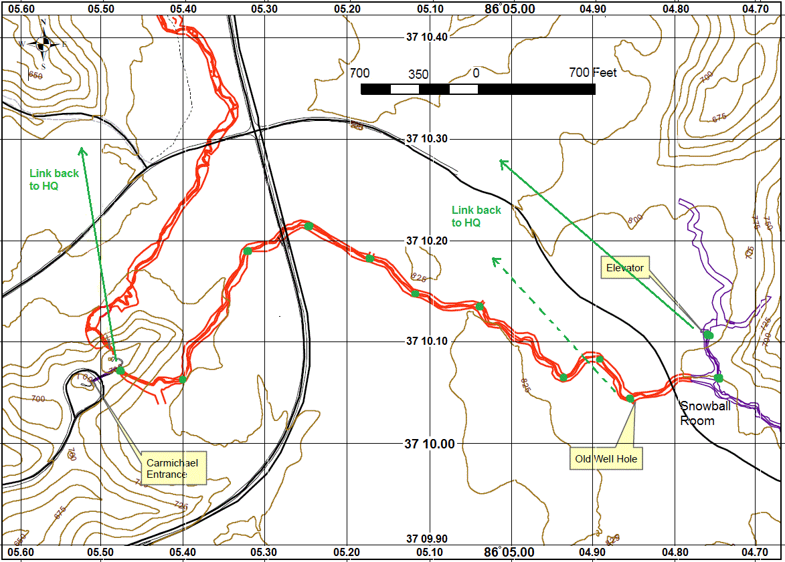
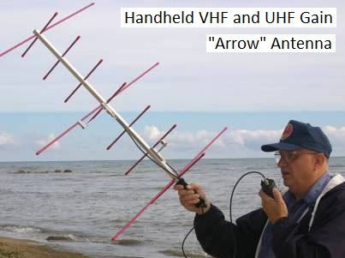
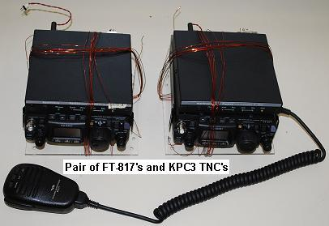
VHF/UHF Hardware – The Cave teams will carry either the D72 handhelds (in the 3” pipe enclosure) or D700 (heavier black box) radios as shown on the first page of this application. The larger radio is required for the vertical links but may also be used if we cannot come up with enough of the D72 radios. In addition to the small 6” whip antennas on the radios, a handheld beam antenna as shown here may be required for the vertical rock penetration link at Carmichael. Such an antenna would not generally be wielded while walking and only used at the fixed vertical link locations.

HF Hardware: Once the HF test team has determined the best band with the least noise, using voice and SSB, then these two FT-817s with attadched KPC3 TNC’s will be used to verify packet operation. The antennas will be ¼ wave lengths of wire from 8 to 65’ long. A microphone is used for coordination, but ultimately the attached data modems provide the data link. The TNC’s are set up to beacon and to be digipeated by each other so that we can see if they are decoding without actually having to have laptops at each location.

Procedures: To keep the test simple and with minimum impact, there will be no test equipment. The length of each link is simply adjusted for at least 95% reliability (19 out of 20 packets successfully received). This should give about a 70% reliability end-to-end figure per packet over a 7 hop length. This probability is enhanced to about 99.8% by the inherent 5-times retry function built into the protocol method. Both text messages and position coordinates will be exchanged. Notice that the map (higher detailed one will be used) has a lat/long grid so that operators can manually enter their coordinates and properly appear on any PC maps viewing the test on the internet. Each digipeater also reports its own position (as manually entered by the operator) so that everywhere in the system the locations of these devices can be seen.

D700 Radio Settings:

The packet settings in the D700 radios must be made prior to the test using a PC on a serial port.

Packet Mode:

MYCALL CAVEx
UIFLOOD HOP,ID <= Enables HOPn-N digipeating with ID of last digipeater
UITRACE TEMP <= Enables TEMPn-N digipeating with trace
UIC 10 <= Shortens the dupe filter to allow for 12 second packets
TXD 20 <= Shortens packet header
BEACON E 0 <= turn off packet mode beacon

APRS mode: (can be set from front panel and then SAVED into PM5)

MYCALL CAVEx
GPS NOT USED
MY POS <= Set when placed from Map coordinates
POS AMBIGUITY OFF
POS LIMIT OFF
STATION ICON (digipeater)
STATUS TEXT (Your FCC call)
STATUS TX RATE 1/1
PACKET PATH HOP7-7,HOP7-7,WIDE2-2
PACKET TX AUTO
TX INTERVAL 10 minutes
DATA BAND A
DIGI ON
UIDIGI RELAY <= will add TOP or VERT when placed
AUTO REPLY MSG OFF
RADIO MENU:
DISPLAY KEY FUNCTION MODE3
MEMORY AUTO PM STORE OFF
TX AUTO every 10 minutes
POSITION Manually entered with Keypad when digi is placed

