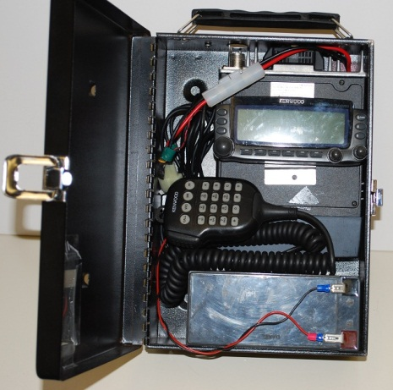
Building and Operating your D700/D710 Cave Digipeater
Bob Bruninga, WB4APR
http://aprs.org/cave-link.html
Rev c 23 Jan 2013
Introduction: The purpose of this enclosure is for portability of a Kenwood TM-D700 or D710 transceiver to serve as a digipeater in caves. It was selected for light weight, ready availability and compactness. It is *not* suitable for wet or dripping locations since it is not at all weather proof. For our first test in Mammoth cave, the cave is dry.
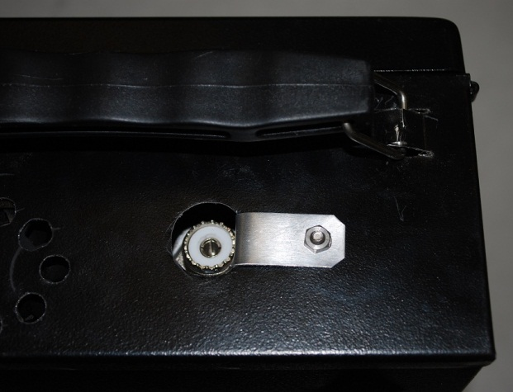
Box: The box is a standard 7.5” x 11” x 4” Cash Box from K-mart, Office Depot and other similar stores. Be sure the lid is flat (Walmart’s are not). It is very light steel (another reason it is only good in dry areas). It is a tight fit for the D700 and my 9 AH gel cells. Note the insulating plastic in the lead to prevent battery shorts. A smaller battery solves the tight fit of the D700 mic cable.
Handle: For portability, the handle should be moved to the top. At first this seemed like a lot of work until I realized that a dremmel tool with small cutoff wheel could quickly cut the slots in the box and a slight hammer blow to a screwdriver could bend out the metal loop to hold the handle. Just prop the box on something about 1/8” thick to support the tab on either side of the cuts. Unbend and then re-bend the handle supports.
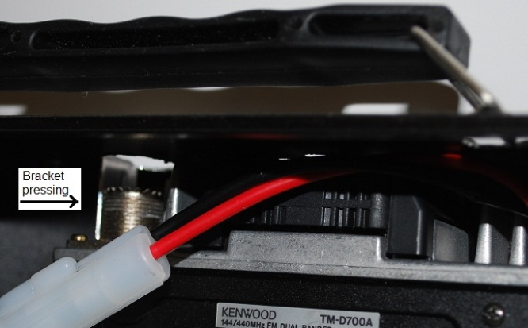
Antenna Bracket: This may not be required, but I did it anyway just to make sure the box was acting as a proper ground plane right at the antenna point. It is an aluminum bracket bent at almost 90 degrees so that it can be slid inside along the edge of the SO-239 antenna connector and then when it is screwed to the box on the outside, it tightly presses against the connector for a tight connection.

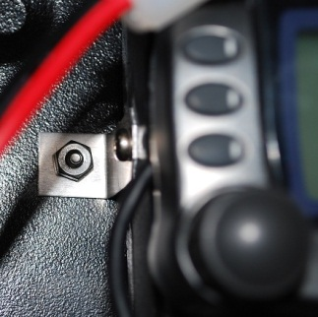
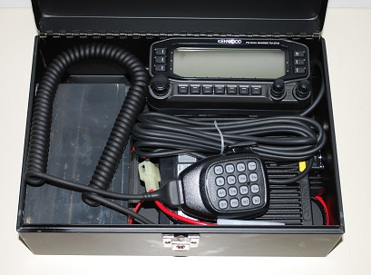
Radio Bracket: The D700 radio is raised about 1/8”off the bottom of the box using little 1” square pads so the speaker is not blocked. This location is maintained on the right side of the radio by a standard support screw going through the right side of the box. To match it, there is also a radio bracket on the left inside edge of the radio as shown here going to the back. Be sure to screw it to the radio before you put the radio in the box, unless you cleverly retained the original plastic quick-removal knobs that came with the radio.
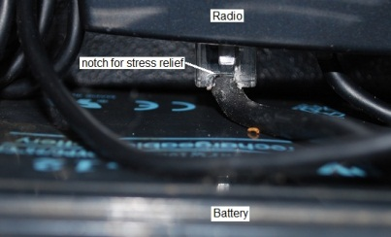
The D710 does not need either the radio or antenna bracket since the two Fan screws closest to the antenna can be used through the top of the box and a 1/8” spacer to support the radio and provide continuity. My control panel just fits in vertically so that I could leave the GPS glued to the back of it in place for later mobile use. In this way, the left side of the radio must be flush with the back of the box so the control panel will fit in the box without the lid pressing any of the buttons. I canted it up on the right side 1/8” to give some speaker access, but not on the left. A side screw just to the right of the clasp (not shown here) holds the right side of the radio.
Mic Cable: With my slightly large 9 AH battery, the tightest fit was the Mic wire. You can see that I cut a tiny 1/16th inch notch in the RJ45 connector to allow for a little better bend of the cable. Do not cut into where the cable is actually clamped, but just a tiny notch. I think it would have fit anyway, but it looked close. The battery is sideways and so you have to put solid insulation in the lid to prevent the battery terminals from being shorted when closed. For the D710, the battery fits upright OK.
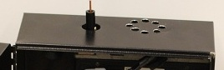
Antenna: The antenna is just a 1/4 wave length of #12 electrical wire soldered to a banana plug and shoved into the radio SO-239 connector for a nice snug fit as shown here. Since the box is not a full size ground plane, an EZNEC model (below) suggested a 20.4” long wire was resonant. I used the soft wire copper so that it bends easily instead of poking everyone along the way. Also notice the 8 holes over the fan. They match exactly the holes in the fan (pointing up, another reason this is not a weather proof enclosure).
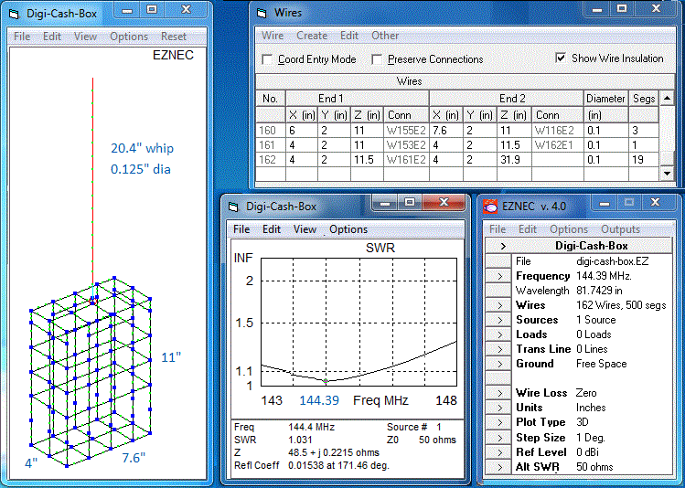
Battery Power: The D700 draws about 630 mA and the D710 draws about 750 mA just on receive. This can be reduced by 100 mA on the D700 and by 50 mA on the D710 by turning off the unused band-B receiver. The Transmit power is less, since the duty cycle for an APRS digipeater is only about 1 second out of every 20 or 5%. This equates to an average transmitter power draw of say 600 mA operating at 50W, 250 mA at 10W, and about 200 mA operating at 5 watts. Combined, then you need a little more than about 1Amp-Hour per hour of operation. The 9 AH gel-cells I am using should last a good 6 hours or this heavy cycling test period. You might get twice that life for routine cave operations with less overall traffic.
Settings REQUIRING PC: The digipeater settings for a D700 MUST be made at home with a serial port and PC PRIOR TO PLACEMENT. The important command is UIFLOOD HOP, ID. This sets up the radio to support HOP7-7 paths and to add its callsign (only displays if this is the last digi heard).
Menu Settings: From the front panel (or serial port) set MYCALL to CAVE# or CAVE-# for two different series of digipeaters as needed.
Placing the digi: After setting the digi in place, use a cave map (example below) to enter the lat/long digits using the POS button and microphone Keypad. This is important for others to see where the digi is located. Once the degrees and minutes are entered, only the last two digits in both lat and long are needed to move the digi almost anywhere in the area. Using the map below with the lat/long grid it is easy to estimate the last 2 digits. Just remember that longitude in the USA goes east to west.
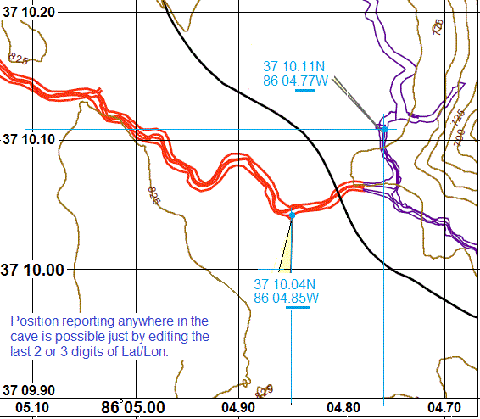
Transmit Power Compensation: It is very important to remember that the 50W digipeater capability of the D700/710 radio is unbalanced when operating in conjunction with other in-cave digipeaters using only the 5W walkie-talkies. For this reason, it is best to operate the D700/710 only at 5 watts so that the two-way link is balanced. For those vertical links that need the 50Watts for rock penetration to the surface, you must remember to temporarily set it to only 5W low power during distance-testing when placing the adjacent in-cave 5W digi. Then once that distance is determined, then return to High power for the vertical penetration to operate properly.
Another way to compensate for the high power during distance-testing (without having to go back to the D700/710 digi) is to carry a small SMA 10 dB attenuator when placing the adjacent 5W digipeater. Place the 5W attenuator on the HT while doing the range testing to find the farthest operating distance from the 50W digi. When the best operating position is found with that 10 dB attenuation, then you can remove the attenuator for normal operations and have a good sense that the 50W digi will hear the 5W digi.

