APRS Tracker for Balloons
Bob Bruninga, WB4APR
Bruninga@usna.edu
410-293-6417

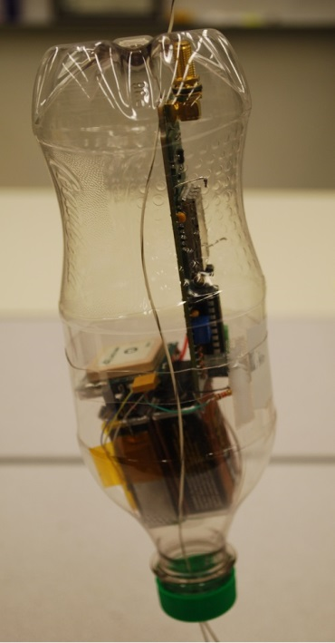
This is the packaging I used for the Byonics.com MT-400 tracker. It uses a typical soft-drink bottle cut open in the middle so that the electronics can be inserted. Then one must very carefully use a heat gun very lightly to just perceptibly cause one half of the bottle circumference to very slightly contract. When done successfully, the two halves will then make an excellent water proof mating. Then cover that joint with some tape to hold it together.
Notice the batteries are at the pointy end so that the largest empty volume is at the top for flotation. Flotation is required in this area since the chances are significant of a water landing in the Bay or Ocean. The holes through the plastic have to be sealed just before flight with waterproof “goop”. That is a brand name of clear Goop from Home Depot.
Notice also that we had to power the Tracker with two 9v batteries. Although this gives double life, the real reason is tht this particular Byonics.com MT-400 tracker simply has too much cross-talk interference if the Tracker and the GPS are powered from the same battery.
Figure 1. The completed water-proof, solar heated tracker
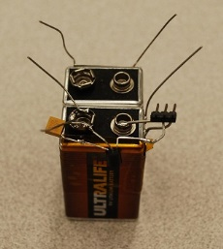
The total mass of this package as shown is 155 grams. But prior to flight, we would wrap one layer of transparent bubble wrap around the internal electronics to provide an additional layer of insulation. This gives a sense of “double glazing” on our little package making it retain solar heat and therefore stay nice and warm in the usual -60C outdoor temperatures at high altitudes. Far m ore effective than trying to simply insulate it with foam (what most other people try to do).
Notice also that the plastic bottle provides the smooth, not-sharp edges required by the FAA so it does the least damage on uncontrolled descent.
To begin the packaging, we solder several support wires to the batteries to support the rest of the electronics. Most 9v batteries have veryeasy to solder tinned casings. But in this case, with Lithium cells, the case is aluminum and impossible to solder to. SO in this case, we cut the case off of an old regular 9v battery, and cut the sides into flat pieces. We then taped these flat pieces of tinned metal to the aluminum battery and did our soldering to these pieces. You can see the yellow kapton tape all around the batteries to secure them to the tinned material. Figure 2. Battery Preps
Notice also, how we provided for a convenient on/off switch by using a 2 pin connector header. (3 are shown but the 3rd pin is only part of the support (soldered to the side of the battery) and is cut off for flight so no one is confused by the extra pin.) Then any commoon two-pin jumper form any ole’ electronics board can be placed on the pins to power up the GPS. Notice also the small 3 terminal 5v regulator that reduces the battery’s 9v down to the regulated 5v for the GPS. I also added the small orange capacitor not only to provide electrical stability to the 3 terminal regulator, but also provide additional mechanical stability to the 5v output pin which will be soldered to a red wire going to the GPS 5v input.
Next then we mount the GPS to three of these wire support as shown in the next photo. Notice how easy it is to solder these wires to the tinned shield on the bottom of the GPS.
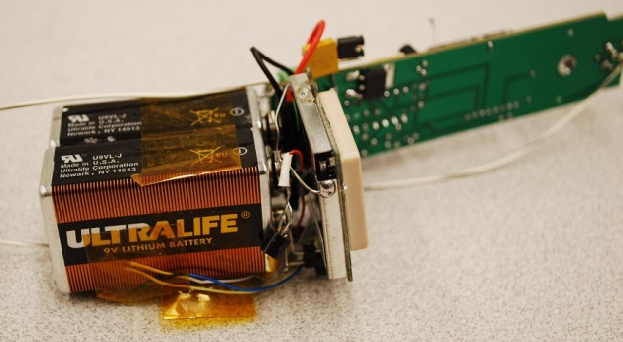
Figure 3. The GPS mounted to the battery wire supports and the other two-pion on/off jumper for the Tracker in the background behind the orange capacitor.

In this photo you can also see how the other 3 unused wires of the GPS are just taped to the side of the battery to keep them from shorting to anything else. Here you can also see the red wire coming from the GPS to the 5v terminal of the 3-wire regulator and covered with white heat-shrink. The next image whows how we similarly attached the Byonics.com MT-400 to the other battery with only two more structural wires, again soldered to the corners of a tinned piece of metal cut from a standard 9v battery case.
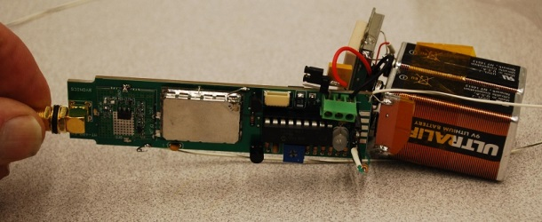
Figure 4. Showing the mounting of the PCB to the other battery
Not shown in these pictures are two more longer structural wires soldered to the back of the MT-400 circuit board down to the tinned shield on the GPS. In the next drawing we have manually drawn them onto the photo (which was taken before the wires were added).
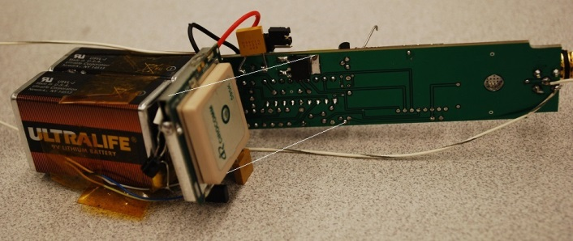
Figure 5. Showing the location of the final two structural wires to hold the circuit board (white lines)

The next two views are just additional views of the nearly compelted package. Yet to do are wrapping of the guts in a layer of small bubble wrap, the sealing (tape ) of the joint between bottle halves,and the goop sealing of the antenna and counterpoise wires where they penetrate the plastic bottle.
Notice also the two “switch” locations where a dual pin jumper must be placed to turn on both the Tracker (from its 9v battery) and the GPS from its 9v battery.
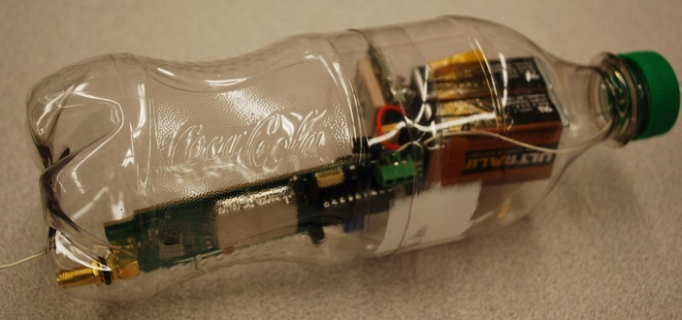
Figure 6. Showing the nearly complete unit with antenna coming out the left through a hole in the bottle and the counterpoise wires going out the other end (down) through the cap. Both the antenna wires and the counterpoise are 19.5” long from where they connect to the bottom of the antenna connector.
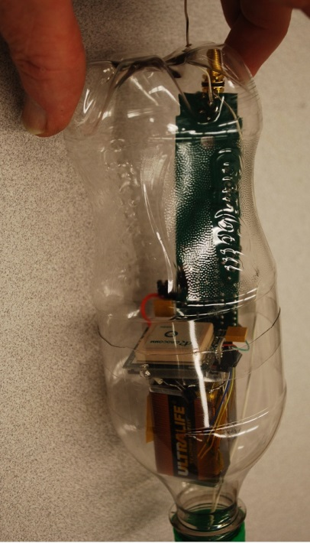
The flight unit was progarmmed with the callsign of the Naval Academy Amateur Radio club W3ADO-11 and set to beacon every minute. The image below is similar to the set-up page used with a PC to program the Tracker. It’s settings are different, but we don’t have an image of the programming page for the actual W3ADO-11 unit.
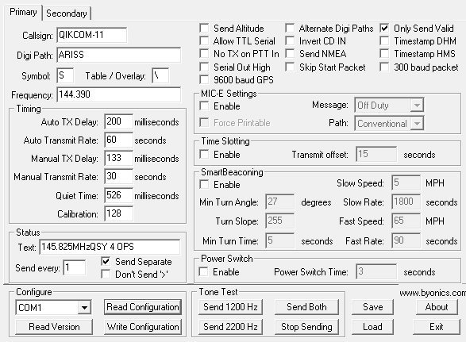

Figure 7. Another view showing the bottle in tis flight position. It hanges from the antenna. But there is a half-knot in the antenna wire inside the bottle to the bottle is supported without any stress on the actual antenna solder point on the antenna connector.

