
APRS TRACKER Manifesto:

Welcome to APRS!
Bob Bruninga, WB4APR See: www.aprs.org/localinfo.html

Thank you for investing in this exciting aspect of the Ham radio hobby. You will find APRS as a great real-time communications and information distribution system that keeps everyone informed of all surrounding APRS and other Ham Radio activity and that also facilitates communications by data and voice among all members of the APRS network.

In that regard, APRS was intended to be a two-way communications system between operators. Although you have purchased an APRS “Tracking Device” which is sometimes connected to only a transmitter, you can still fully participate as an operator in the APRS net. The best way to do that is to connect your APRS tracking device to a transceiver and although the receiver is not used for data, the receiver and speaker with a CTCSS tone can still be fully used as an APRS “intercom” channel for back-channel voice coordination and radio-proximity detector. In effect, you get dual use out of the radio (Data and Voice)!
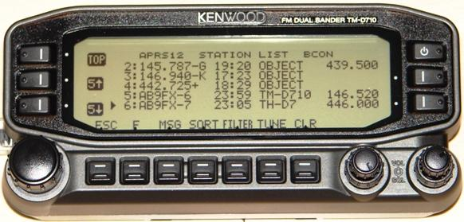
As noted on the web page above, placing the frequency of your voice receiver in the Beacon Text of your tracker, everyone that receives your position report can also then see how to contact you, and include you in the voice net as needed. If you use the proper format then your frequency will show up on other mobile displays as shown here. This way, other operators can then easily tune to your calling channel and make needed contact. Although any voice calling channel can be used, we recommend using a radio with CTCSS-100 and tuned to the APRS data channel (144.39 in the USA). This way, your speaker is muted to all packets, yet you can be called by voice by anyone using PL-100. Another advantage of this method, is that your speaker also becomes a “radio proximity detector” to other similar mobiles in simplex range. This is called “Voice Alert”. See: www.aprs.org/VoiceAlert3.html

Including your own voice monitoring frequency in all of your packets is just part of the use of the APRS frequency parameter. Under the New-N Paradigm, the locally recommended voice repeater for all travelers is also being transmitted by most digipeaters as an object. This informs travelers in the area, what frequency is useful to them right there, right now. These objects show up in the station list of all APRS stations for easy visibility as shown above.

If your tracker device has its own transmitter and no receiver, you can still include your monitoring voice contact frequency, paging number, email address or other call-back info in a periodic beacon to facilitate communications with you even if you are not onboard. If not in every packet, then once every 10 minutes is suggested. This meets the objectives of the Universal Ham Radio Text Messaging/contact initiative. See: www.aprs.org/aprs-messaging.html

Using Voice Alert, frequency beacons and local frequency objects fulfill the objective in APRS of facilitating communications between all operators in any situation.

Enjoy! Bob, WB4APR

