A Prototype 29MHz PSK31 receiver for use with VHF / UHF FM transmitters.
The receiver detailed here is intended to receive a number of simultaneous PSK31 transmissions on a nominal frequency of 29.450 MHz, downconvert them to 10.7MHz where they are passed through a two pole crystal filter limiting the RF bandwidth to 7.5kHz. The signals are then applied to a voltage controlled variable gain amplifier. This AGC has a range of 43dB. The control voltage can be self-generated within the VGA chip or it can be generated further down the RF or audio chain. In this application the internal detector is used. With the maximum amplitude limited by the AGC, the 10.7MHz RF is applied to a product detector based around a diode ring mixer.
The demodulated audio is low pass filtered and buffered. Performance figures are detailed below.
This design can be used as a basis for the current CubeSat opportunity but would benefit from some updating to reduce complexity and reduce power drain. – It was designed in 2009 for use on a 28V supply where power wasn’t too critical.
The circuit here includes an output at 10.7MHz intended for an SDR transponder. We don’t need that output, the 280kHz filter or the DC switching circuits that power down the AGC and audio circuits. The images below were produced in 2009 / 2011
As an alternative, the front end, RF input mixer and filtering could be used with a DSP based system as proposed, but working with a bandwidth limited signal at 10.7MHz instead of 28M. That would remove all components after the crystal filter matching and may give the DSP an easier time.
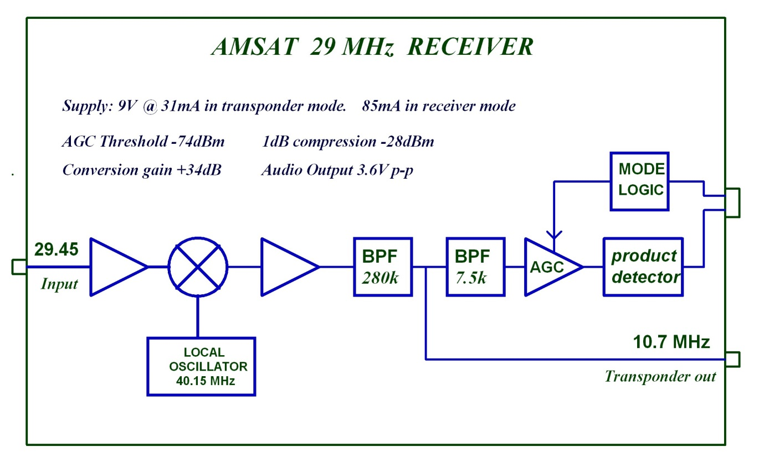
Figure 1. Block diagram of the original prototype which included a 280k 'linear transponder' output
- I would suggest replacing the front end bandpass filter with a low pass and leaving spaces for antenna matching components.
- Replace the dualgate mosfet and transformer with a modern 3.3 or 5V MMIC
- Increase the gain so that the AGC onset is closer to -90dBm rather than -74dBm
- Possibly change the buffers either side of the crystal filters for 2 op-amps. e.g LT1818.
- Remove the 5V linear regulator and run 5V circuits from the Clydespace 5V or 3.3V SMPSU
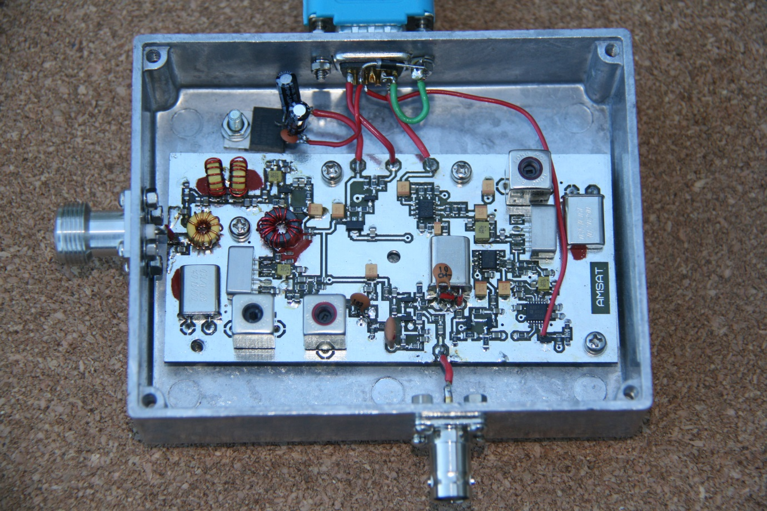
Figure 2 Receiver PCB is 105 x 54mm
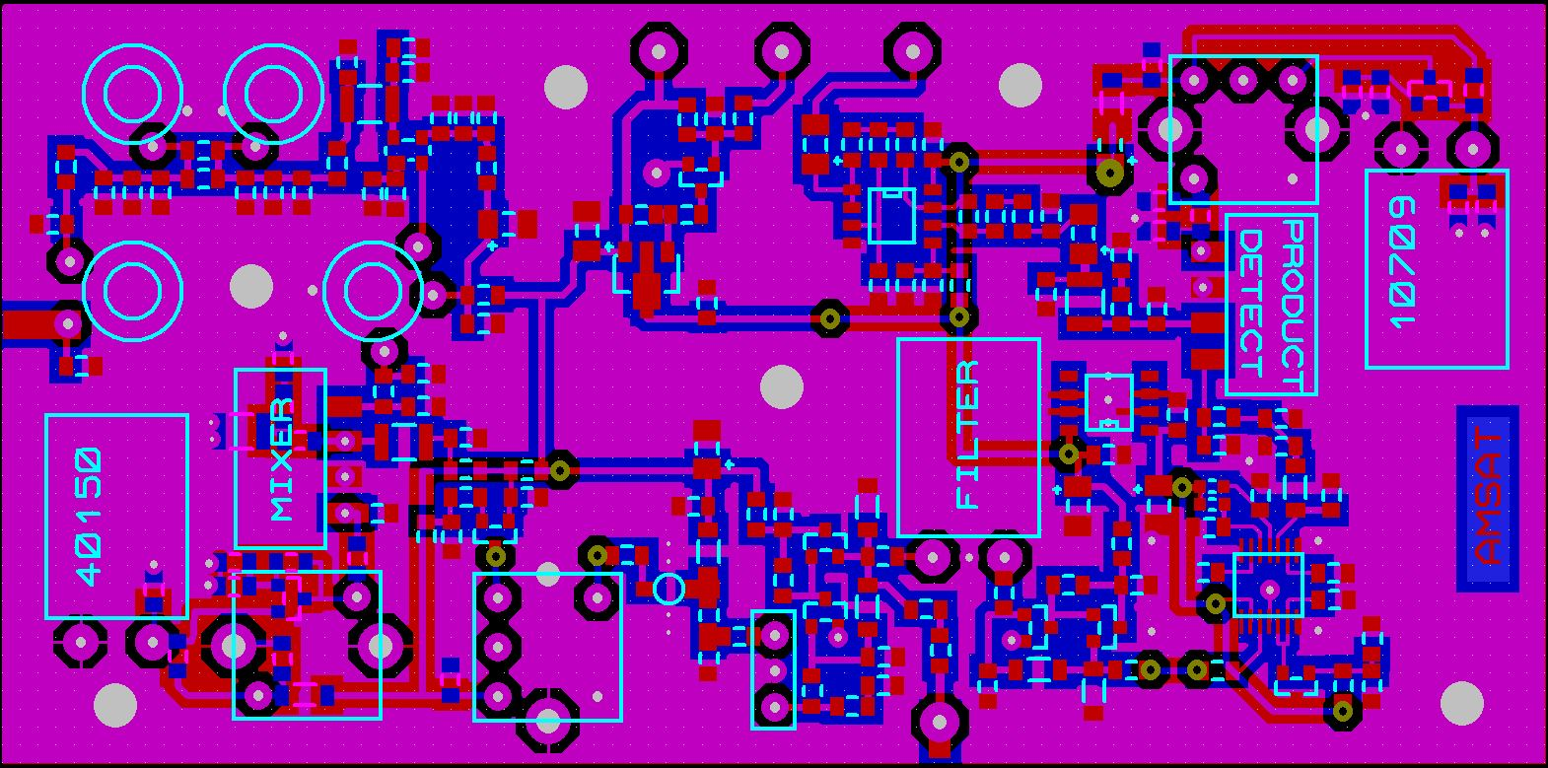
Figure 3 PCB component layout. – Lots of unused space !
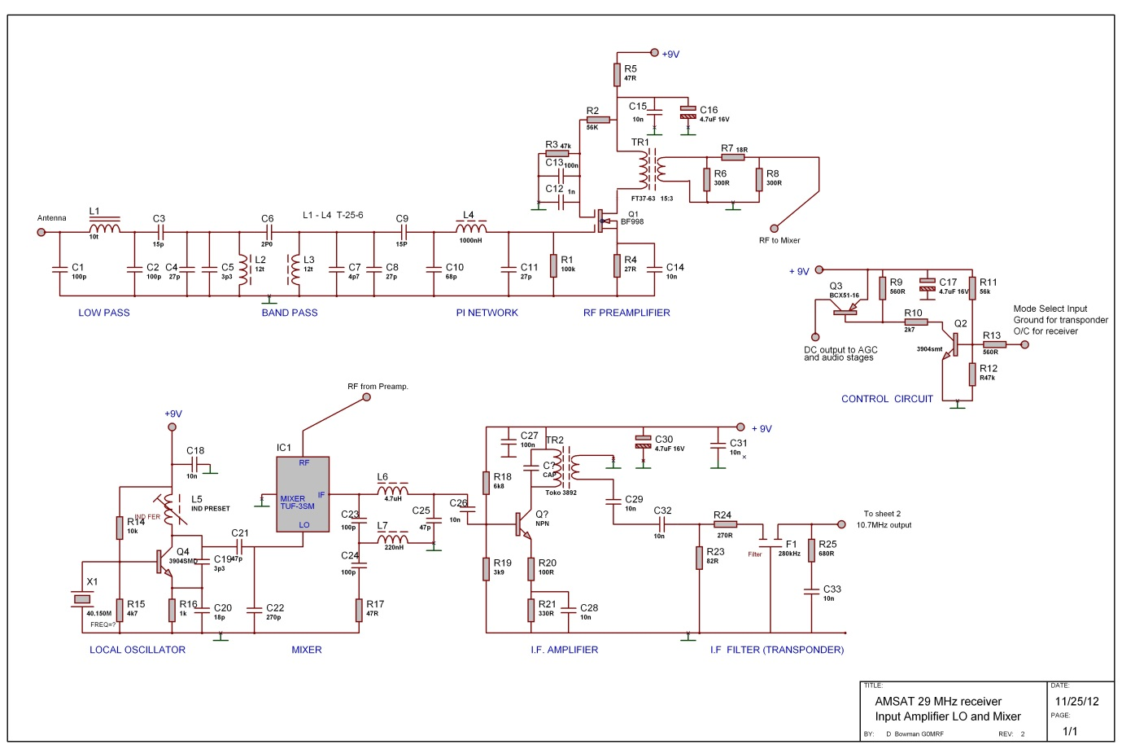
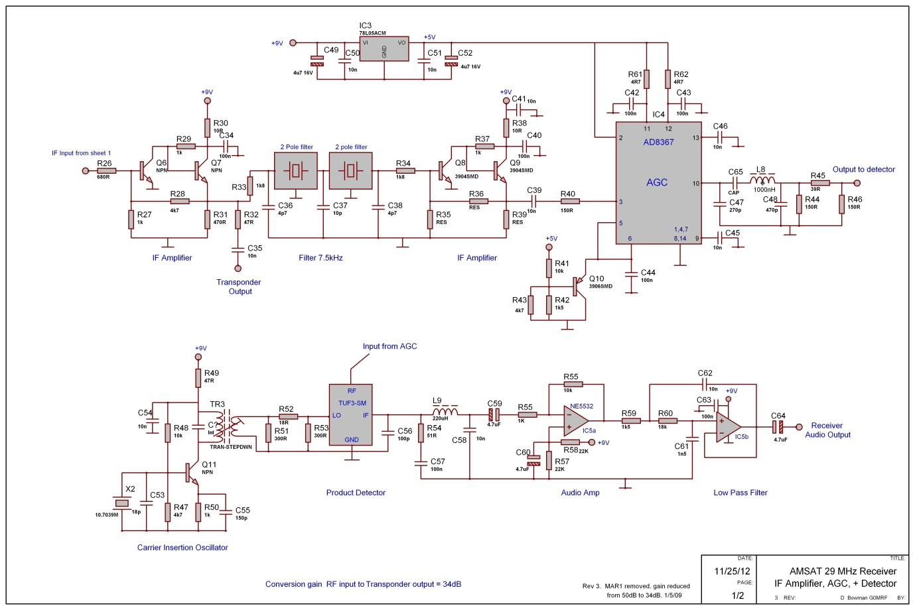
Where to set an AGC?
Peter and Bob will have a more considered opinion for this but the following may help.
At 400k altitude and 2 degrees elevation the path loss is -128dB to a satellite with a range of 2100km
A 25W transmitter into a dipole will produce about -86dBm at the satellite (less the efficiency of a short antenna) So perhaps -94dBm (?) at the receiver.
A beam running 400W could produce 2kW ERP and at 35 degrees elevation the range is about 660km. The signal level at the satellite is now around -55dBm less the antenna….so perhaps -63dBm.
So a range for the AGC of 94 – 63 = 31dB. As the Analog devices chip has 43dB, this should be sufficient, although multiple users will reduce this range.
My ‘ball park’ guess would be to set the AGC to around – 85dBm and allow signals below that level to appear at a lower audio level in the passband.
A quick test from this evening:

RF Input level dBm | Audio Output p-p mV | AGC control voltage mV
-94 | 360 | 20
-84 | 1080 | 20
-80 | 1800 | 23
-74 | 3600 | 25
-73 | 3600 | 65
-70 | 3600 | 135
-65 | 3600 | 234
-60 | 3600 | 334
-55 | 3600 | 436
-50 | 3600 | 538
-45 | 3600 | 637
-40 | 3600 | 738
-35 | 3600 | 836
-30 | 3600 +distortion | 926
-25 | 3600 + distortion | 972

Thanks

David G0MRF 20/Jan/2014

