PSAT2 User Operations Manual
(rev-h) 7 May 2021

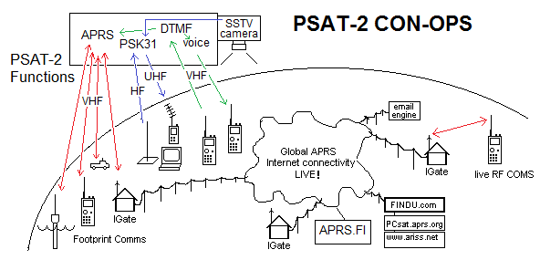

PSAT2 Capabilities Summary: PSAT2 contains multiple transponders which are used in the following descending priorities as power permits. The concept of operations is to give PSK31and SSTV guest payloads from Brno University, priority. But Voice and DTMF are also an exciting new APRS capability too. Conventional APRS digipeating is of lower priority and may be off to minimize channel congestion.

1st PSK31: 29 MHz uplink to UHF 435.350 MHz FM downlink like PSAT,
2nd SSTV: SSTV images transmitted in same PSK31 downlink when power avail
3rd APRS-to-Voice: packet uplink to Voice downlink
4th DTMF Grids/Msgs: DTMF grids or msgs are converted to Voice& APRS
5th DIGI: APRS digipeater identical to PCSAT-1, PSAT-1, ISS
Narrowband Receiver Challenge: The PSAT2 comms board is commercial off the shelf (Byonics) and all modern transceiver modules conform to FCC narrowband channel designs. This is problematic for a satellite uplink because of the +/- 3Khz of Doppler.
So first, your radio must set modulation to narrowband (NFM, not FM), second, you will only be able to get into the satellite with zero Doppler within a few seconds of max elevation, all other times, your packets or DTMF will splatter out of band and you are only jamming other users. Of course, if you have an expensive all-mode radio, tht can tune on FM in 1 KHz steps, then you can work through the pass. Good luck.

Center-Pass Operations: So please do not transmit if you are not tracking Doppler in 1 Hz steps at any time other than the few tens of seconds at the middle of the pass (when the link is strongest for you anyway).

Channel Capacity: Expect only a few user successes per pass due to channel congestion. APRS and the DTMF are ALOHA protocols and users share the uplink channel blind with all other users. The theoretical maximum throughput of an aloha channel before the channel degrades due to collisions is 18%. With packets lasting 1 second and DTMF lasting 4 seconds each, and with the channel being half-duplex (cannot receive 60% of the time while transmitting) then the optimum throughput is about 10%, or about ten packets per minute. Thjs equates to no more than a dozen or so users in the 6 million square mile footprint (entire USA). So users must share equitably and not hog the uplink. And, as noted above, only transmit when you are close to zero Doppler. And Please transmit rarely.

Unattended beaconing on the APRS satellite channel of 145.825 is not authorized.

PSAT2 TELEMETRY: PSAT2’s health/status Telemetry is transmitted once a minute in the standard 5 channel APRS telemetry format but original Kenwood APRS radios do not decode this special format they will only display the callsign and ?? meaning the format is not recognized. But in June 2019, Kenwood released a new version of firmware for the D72, D74, and D710 radios that will capture and decode these packets.. Only channels 1 and 2 are human readable. The other three are temperatures which need decoding programs. The format is:

PSAT2,ARISS:T#mmm,ch1,ch2,ch3,ch4,ch5,01000000

mmm is the telemetry serial number in minutes.
Ch1 is the Bus voltage in tenths of a volt
Ch2 is battery current in mA. Below 500 are discharge, above 500 are charging
Ch3,ch4,ch5 are temperatures that get larger as the temperature goes down.
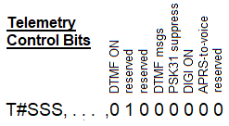
PSAT2-MODE Indicators: The status of the operating modes of the spacecraft are included in the ending string of 8 bits as shown here. The value of 01000000 is the reset-default.

ADCS Telemetry: The attitude dynamics and Control processor has its own telemetry format. This format is shown as:

S#OOOOMM,CzWTS ⬅ STATUS portion of packet

S upper case means the even minute, lower case means it is on the half minute
#OOOO is the orbit number (up to 9999, 260 days +)
MM minute in that orbit (00-95)
C ADCS Command mode (0,1,2,3) (Launched with 0)
z 6 day countdown to (reset to slot0) (base 62, z down to !) every 2.83 hrs
W WOD telemetry RATE (1,2,3,4, etc. Every W MA counts) 0=off
T Telemetry count down timer (Max 14 minutes)
S Sun Telemetry Enabled if 1. Normal if 0.

When WOD=1 samples are every 2.5s, when WOD=2 samples are every 5s and transmits every minute [Best data]. When WOD=8 then samples are every 20 seconds and S# telemetry is transmited every 4 minutes to keep channel load low.

If the Sun or magnetic vector data are enabled then vector data is added on the end of these packets in these formats:

S #000026,0z100,eEBeEBeEBeEBeEBeEBeEBeEBeEBeEBeEBeEB
M#000026,0z100,EDSEDSEDSEDSEDSEDSEDSEDSEDSEDSEDSEDS
I #000026,0z111,XXX,YYY,ZZZ,xxx,yyy,zzz

The vectors are easily plotted. Just use upper-case A-Z as positive values 1 to 26, and lower case a-z as negative values to give you 12 samples of the vectors.

Digipeater/Channel status: The 6th bit indicates if the DIGI is on or off and what uplink frequency is being used. When the digi is ON, then uplink is on the normal 145.825 MHz. When it is off, then the DTMF uplink is on 145.980. The path is via ARISS in case there is a lucky pass near the ISS which might digipeat it a second hop.

PSAT2 Receiver Wake-up: The receiver goes to sleep after 10 seconds of no activity. So, the first user per continent will have to wake up the satellite receiver with a 1 second PTT prior to sending any packets or DTMF. Do NOT do this subsequently because it is just wasted channel congestion jamming other users.

I. PSK31 Texting Operations:

The BRNO transponder downlink can be displayed in any PSK31 program listening to a UHF receiver on 435.350 MHz FM. It will display a waterfall similar to the one shown here. There are 3 signals here. The PSAT2 PSK telemetry on the left around 300 Hz. A user with negative shifting Doppler is next around 800 Hz (remember the live signals are the top line of the waterfall, history goes down the page. And then there is a signal at about 1000 Hz that is constant. This is because that third signal is using K0SM’s Doppler PSK software for uplink. It pre-compensates for the satellite Doppler on the uplink to maintain a constant tone in the FM downlink.

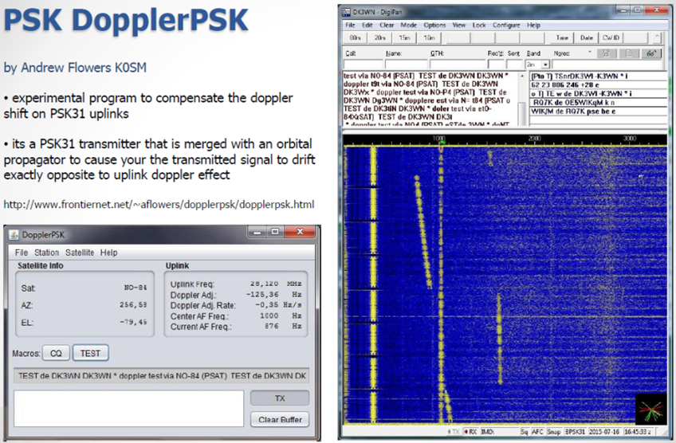

Automatic Doppler Tuning Warning: Every step of tuning a radio for Doppler will cause phase changes that will cause PSK31 to lose lock and garble. Since this is FM, only tune radio in big steps to stay in FM passband to minimize the number of times these steps have to occur. Every 0.5 or 1 KHz on FM should be fine.

The ten meter uplink will require from 25 to 100 Watts using a SSB transmitter on 29.481 MHz and a computer running another copy of PSK31 software or even better, K0SM’s DopplerPSK. His software can transmit the entire pass because the transponder is full duplex with the downlink on UHF. This will allow continuous simultaneous conversations with everyone on the channel in real time.

II. Slow Scan TV (SSTV) Downlink:

Every 2 minutes or so the SSTV camera will take a picture. If it is not looking at sun, or black (looking at space) it will downlink in the middle of the PSK31 waterfall downlink between 1200 to 2300 Hz. Since this is in the middle of the transponder audio spectrum, PSK31 users should stay between 550 to 950 Hz to avoid interference.

III. APRS-to-VOICE Synthesizer:

When this mode is enabled, you can send a special APRS packet Message to be spoken using a special format. First, the APRS message must be sent to the special callsign “PSAT2-SAY”, Second, there must not be any digipeater path in the packet. If the packet has a digipeat path, the SATT4 will digipeat it and not speak it. Third, the first word of the message text must be your 6 character callsign (pad with spaces). Fourth, the next word must be exactly “sez” in lower case followed by the text message to be spoken:
“CCCCCC sez hello world…, etc”

The message to be spoken must be in lower case otherwise the synthesizer will try to spell out each upper case character like it does for the callsign. If all these message elements are correct, then the spacecraft will speak “CCCCCC says hello world… etc” or whatever follows the “sez”.

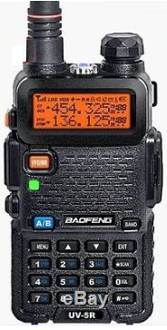
IV. DTMF (Touchtone) Gridsquare and Voice Response:

The DTMF experiment will not normally be on because it takes much longer to send a DTMF string and this adds lots of collisions on the uplink and low probability for users success. The idea for this experiment was to allow use of simple FM radios such as shown here that do not have built-in APRS so more users can communicate via PSAT2. DTMF can be used for Gridsquare reporting. DTMF grids are spoken and are converted to an APRS packet on the downlink. If the DTMF experiment is ON, then APRS digipeating is lower priority and will not normally be on. But DTMF takes several seconds and must be error free. So, operations require the DTMF string to be preloaded into the radio’s many DTMF memories.

The Grid DTMF uplink consists of a beginning *, then the 4 digit grid and then the 10 key callsign field ending with the # key as shown here.

Grid DTMF Format: *ddddCCCCCCxxxx#

DTMF CCCCCCxxxx Callsign Encoding: The callsign digits are simply single presses of each callsign letter key followed by a 4 digit special code that tells PSAT2 how to read those letters (shorter calls, pad with 0). The final 4 x’s represent a “keycode” that encodes the positions of each of these letters on each key of the user’s callsign. Note, the Q and Z are located on key 1. Rather than belabor how the xxxx key code is derived, you can use the on-line keycode calculator at http://aprs.org/PSAT2Translator.html.You only need to do this once for your callsign. For example, the USNA Radio Club’s call W3ADO results in a code of 1116. There is a callsign/grid/code generator on the PSAT2 web page http://aprs.org/psat2.html

GRID SQUARE Format: *GGgg…

With only 4 digits available, there is not room to include alpha characters for the first two grid letters, so we took the top 99 populated grids and assigned them a pair of digits according to the map below.:

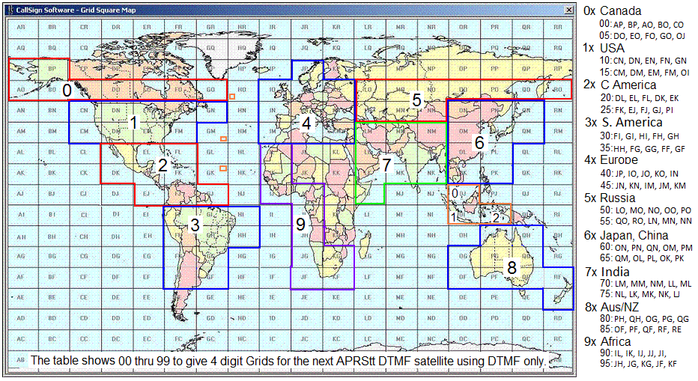
Figure 18. Worldwide APRS DTMF Map for PSAT2

The first two digits correspond to the 99 populated grids illustrated in the outlined areas, the first digit representing the greater continent, the second defining the order of its appearance as read from left to right, top to bottom in said area, and listed on the right. For example, central Alaska Grid BP in the “0x” group (Canada and Alaska) will be identified by 01, the 01th Grid listed on the right. The Grid FN around Maine will be identified in the USA group “1x” as 13, the 3rd grid in the 1x list..

The second pair of two digits of the grid square are used as-is from the Maidenhead grid system to indicate which 10 x10 grid within the lettered block. The lower left subgrid is 00 and the upper right subgrid is 99. For example, the furthest bottom left region of Box FN will be 1300, while the furthest top right portion will be 1399.

For Hawaii, use the grids HI or HH instead of BK and BL and the capture page will translate those properly back to BK and BL.

V. DTMF to Voice Text Messaging: CNNxxCCCCCCxxxx#

The first key (the C key) indicates this is a message format and the NN indicates the pre-arranged satellite message Number from Appendix A. The pair of xx modifier digits can be used for additional numeric modifiers in some messages, but otherwise are ignored. After these 5 keys, then the normal CCCCCCxxxx# callsign follows. These messages take longer speech on the downlink and so take more power, so this message mode might be turned off to conserve power. A list of all the spacecraft pre-loaded messages is in Appendix A.

Pre-Storing DTMF Memories: Consult your radio user manual to see how to load these grids and messages into your radios DTMF memory.

Sending DTMF Memory: In most radios, to send a DTMF memory, first press and hold the PTT button and then press the radios MENU key to find the message to be sent. Select the message and the DTMF string will be transmitted. As soon as the string begins, it is a good idea to release the PTT so that the microphone noises are not also added to the transmitted tones. When the tones are done, the radio will drop the PTT.

PSAT2 Receiver Wake-up: The first user per continent will have to wake up the satellite receiver which goes to sleep after 10 seconds of no channel activity. This applies to both DTMF and packet. While sleeping, the receiver only listens for 0.1 second every second or so, and that is too short to capture a packet. So the first person per continent should hold the PTT down for 1 second prior to that first continental packet. Do NOT do it subsequently because it is just wasted channel congestion.

Two-Way Contact QSL Exchange: For a contest exchange, each user must acknowledge (QSL) another user’s contact number. To do this, there are three special formatted QSL messages (#40, 41, 42) that begin with the letter B followed immediately by the needed contact number xx and then the message number and callsign to complete the uplink

Bxx40CCCCCCxxxx# “Q S L, your number --, My number is *.
Bxx41CCCCCCxxxx# “Q S L, your C Q number --.
Bxx42CCCCCCxxxx# “Q S L, your C Q number -- and thanks for the contact.

* In #40, the * auto increments the CQ number to complete this contact.

In this “B” format, the order of the message number (40, 41 or 42) and “xx” modifier digits are reversed from the standard Cmmxx… message format. This is so that the sender can manually enter the “Bxx” consisting of the CQ number quickly and then quickly send one of these three special DTMF QSL memory suffixes that contains the remainder of this special QSL format. … for example “40CCCCxxxx#” Be sure to preload these special QSL messages.

VI. APRS DIGIPEATER OPERATIONS: Up/Down on 145.825 MHz packet

This mode is identical to other APRS digipeating satellites in space and will not be used unless the other exciting special DTMF and PSK modes in this satellite do not work.

APRS Packet Position/Status: During an APRS digipeater pass, typical user operations consist of watching the screen and seeing packets come into the station LIST and be displayed (10 second hold time). Then toggling your BCON button no more often than every 30 seconds or so while manned. Once every 5 minutes if unmanned temporary experiment. OFF if unattended more than a day. If the satellite hears and digipeats your packet, your radio will display “my position” on your screen. You can use the LIST key to explore other user’s positions and status. The downlink should be visible on http://PCSAT.FINU.COM.

APRS Packet Messaging: Not generally authorized for PSAT2 due to the muiltiplication of channel QRM for all the acks and retries. You can manually enter a message to another callsign, or you can press the MSG key while on the LIST or while the packet is still displayed temporarily and enter a quick text message to him. Or you can call up a previous message you have sent and edit its callsign and transmit it. Another lazy method is to simply send your message to ALL.

APPENDIX A: DTMF User Messages

Preloaded PSAT2 General Purpose ARRL Radiograms (40 to 69) and some the students came up with (70-90). Format is CMMxx… followed by the normal DTMF encoded callsign. Some spellings are corrupted here for best speech sounds.

Wherever a blank “--” appears, then the number “xx” will be inserted
Wherever a * appears, the auto CQ number will be incremented by 1 and inserted

40 Q S L, your number --, My number is **. '2-way QSO
41 Q S L, your C Q number --. 'QSO msg
42 Q S L, your C Q number -- and thanks for the contact. 'QSO msg
43 Go Navy, beat Army.
44 Navy Beats Army by --.
45 I am -- years old.
46 Greetings on your berthday.
47 Got your message number --.
48 I am in school grade --.
49 Celebrating -- months in space.
50 Greetings by Amateur Radio.
51 Am having a wonderful time.
52 Really enjoyed visiting with you.
53 Received your package, Thank you.
54 Many thanks for your good wishes.
55 Very delighted to hear your good news.
56 Congratulations on your worthy achievement.
57 Wish we could be together.
58 Have a wonderful time, Let us know when you return.
59 Congratulations on the new arrival, Hope all are well.
60 Wishing you the best.
61 Wishing you happy holidays and New Year.
62 Greetings and best wishes for the holiday season.
63 Our best wishes are with you, Hope you win.
64 Arrived safely at -- hours.
65 Please meet me on arrival at -- hours.
66 D X Q S Ls are on hand at the Q S L Bureau.
67 Your message -- is undeliverable.
68 Best wishes for a speedy recovery.
69 Welcome, We hope you will enjoy the fun and fellowship.
--- New messages -----------
70 Call me ON my cell at -- Oh clock.
71 No cell phone service here.
72 My Cell phone battery is dead.
73 Greetings from AMSAT, Keeping ham radio in space for -- years.
74 My Cell phone charging opportunitees are limited.
75 Call my cell phone on the hour.
76 My Radio power charging capabilities are limited.
77 My next contact time will be in -- minutes.
78 My next contact time is tomorrow.
79 Please send item number --.
80 I am on schedule."
81 I may be delayed by -- hours.
82 I may be delayed by -- days.
83 I may be earlier by -- hours.
84 I May be earlier by -- days.
85 I may quit earlier by -- stops.
86 I may go further by -- stops.
87 We are camping and enjoying it greatly.
88 Sending love and kisses.
89 Contact me on the -- meter band.
90 There are -- of us here.
91 Celebrating -- weeks in space.

ARRL Emergency RadioGram Messages: The messages numbered 1 through 38 are the classical Amateur Radio numbered emergency messages. They should not generally be used because the channel is so unreliable, that it is impossible to tell a real emergency from a test. But to allow for testing, If xx is 90 or more, then the pro-word TEST is included. If xx is 99, then the pro-word EMERGENCY is included

01 Everyone is safe, Do not worry.
02 I am Coming home as soon as possible.
03 In hospital, Receiving care and recovering.
04 Only slight property damage here, Do not worry.
05 I am moving to a new location, Will make contact then."
06 Will contact you as soon as possible.
07 Please reply by Amateur Radio.
08 Need additional radio equipment for emergency use.
09 Additional -- radio operators needed.
10 Please standby for further information."
11 Establish Amateur Radio contact on -- meters
12 Anxious to hear from you.
13 Medical emergency situation exists here.
14 Situation here is worsening and becoming critical.
15 Please advise your condition and what help is needed.
16 Property damage is very significant.
17 RE ACT communications are on channel --.
18 Please contact me as soon as possible.
19 Request health and welfare report.
20 Temporarily stranded, Will need some assistance.
21 Search and Rescue assistance is needed.
22 Need accurate information on conditions at your location.
23 Report accessibility and best way to reach your location.
24 Evacuation of residents from here is urgently needed.
25 Please advise weather conditions at your location.
26 Need help and care for evacuation of sick and injured.
27 Hi, This was Dove in space, -- anniversary.
28 There are -- of us here.
29 Midshipmen really rock.
30 Maritime Emergency Code number --.
31 We are operating on emergency power.
32 We are operating on solar power.
33 This is a voice test.
34 Wow! This is really fantastic!.
35 Midshipmen really rock!
36 Listening.
37 Yusing Aee PRS TT and DTMF really works.
38 For more info, go to Aee PRS dot Org.

