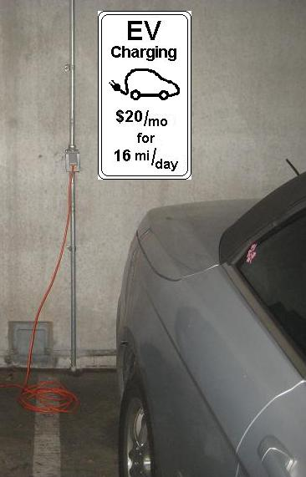
Condo Manager 8 Feb 2012
Address line 1
Address line 2

Dear Condo Manager,
When I visited the public side of your parking garage, I noticed that there are 6 existing standard 115v outlets which are well suited for charging any of the Electric Vehicles on the market. All modern EV’s come with their own charging cord that can be plugged into any 115v outlet. Your private garage was inaccessible and so I could not assess its status with respect to EV charging, but I suspect you have outlets there also.
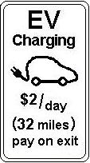
All you need to do to enable an existing outlet for EV charging is to simply put up a sign as shown in the photo (monthly pass for employees), or $2 per day for guests, to be paid on exit as shown here:.
The 115v outlets are not fast, but employees or guests do not need fast charging when they are asleep or working for 8 hours. During an 8 hour charge, the vehicle picks up about 32 miles range from a standard outlet. This is enough for your daily employees or your condo owners to make it to Baltimore, Washington, Easton or Chestertown as shown here.
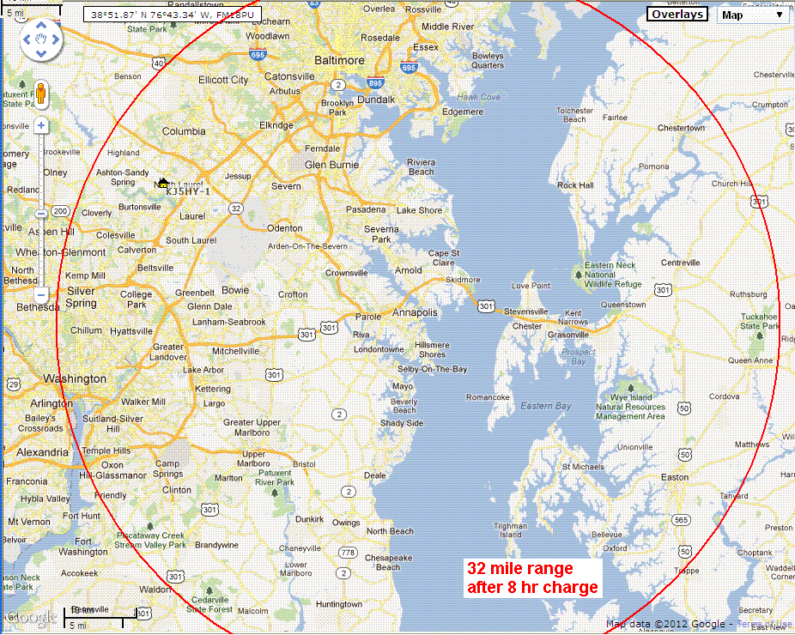
There is too much media focus on expensive “fast” chargers when in most cases (employees or overnight guests) simply do not need a fast charge, but simply a standard outlet to plug into.
Please do not let me dissuade you from the purchase of a fast 240V charger if that is your intention. But if you are putting off the addition of a fast L2 charger, at least in the meantime, enable your employees and owners to simply plug into your existing 115v outlets in your garage.
All you have to do is put up the signs (on only one outlet per circuit breaker). If I can assist in any way, please let me know. I am not selling anything. I am just a 20 year EV owner who is frustrated by not being able to plug into existing outlets due to lack of public understanding of the simplicity of 115v EV charging. For background please see http://aprs.org/payin-to-plugin.html

Your name and email here
Any other association or ID here

