Proposal: EV Charging at the Davidsonville ParkNride (rev c) 2 May 2013
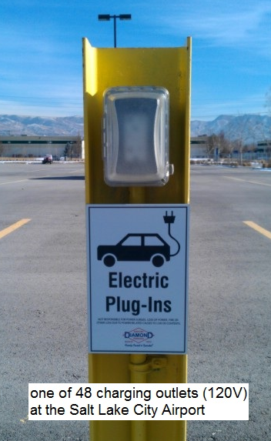
MDOT should consider a Pilot Demonstration of standard 120v outlet (L1) charging as shown here. Approximately 24 EV's could be accommodated for little more than the cost of a single L2 public charging station. Using L1 outlets has numerous synergistic advantages.

Congestion Reduction: Although EV's are excellent for reducing emissions, they do nothing to reduce congestion. That is, unless they are used to get commuters to the Park-N-Rides. This is an ideal use of short range EV’s because the trip from home is small and can be replenished in 2 hours or less from 120v outlets.

Free Electricity Incentive: Providing free charging at the Park-N-Ride would cost only 40 cents a day per commuter and is a tiny cost compared to the typical $6 per day subsidies already being offered to encourage users of public transportation. Limiting an EV to 40 cents is trivial with a simple 2 hour timer on the 120v outlets. This is a bargain to the State of Maryland for incentivizing the use of public transport!

Self Limiting: In addition, limiting charging to only 2 hours per 8 hour workday per outlet, cannot be abused. No one, other than a Park-N-Ride commuter, would leave his EV parked there all day just to get 40 cents worth of free electricity! Especially since there is nothing else to do in the area.

95% Peak Load Reduction: Enabling each of say, 24 outlets for only 2 hours per 12 hour period, for example, would limit the total charge current to a maximum of only about 9 KW throughout the day while serving all 24 EV's. This load is only 5% of the peak load (170 kW) that could occur if standard L2 chargers (7kW) were used and all 24 EV's arrive at the lot in the morning and plug in near the same time.

Simple and Inexpensive: Specially designed standard GFCI outdoor outlets for EV charging at L1 are available for under $30 from Home Depot (Liton model T7591-PEV). The hardware cost for 24 of these L1 charging outlets would be only $720 in contrast to $3000 EACH for a single L2 public charger. Of course the utility wiring and distribution labor and installation costs would be similar to each approach; but with L1, 24 EV's a day are served instead of just one car parked and blocking a single L2 charger!

Disadvantages of L2: L2 chargers make no sense at a Park-N-Ride. 1) A typical patron would be fully charged in under an hour and the charger would be wasted the rest of the day. 2) L2 chargers multiply the PEAK grid loading as noted before. 3) An expensive L2 charger does no more than what a simple L1 cord can do over an 8 hour day, since both will fully charge the EV. 4) The L2 charger cannot serve other commuters since the demand for parking from these part-timers would conflict with the purpose of the lot. 6) Even at L2, a charge takes an hour or so, and there is nothing else to do in the area while waiting.

Security: Locking Covers for standard outdoor 120v outlets are shown above. These lockable covers lock the plugs into the outlet and the locks on the car-end of the J1772 charge cable provides redundancy protection for owners charge cords.

Summary: For the cost of 6 Posts, 24 outlets, and 4 timers and about the same wiring as for a single L2 charger, the SHA could provide a very cost effective EV charging capability for 24 cars per day within the goals of the MD EVIC as well as incentivizing EV use for commuting to public transportation and the commensurate reduction in congestion. The cost to the state for getting these 24 cars off the road and their drivers to take public transportation for the rest of their commute (40 cents a day) is far less than existing public transportation subsidies. Public Transport wins, EV's win. Its low cost. It's a win-win.

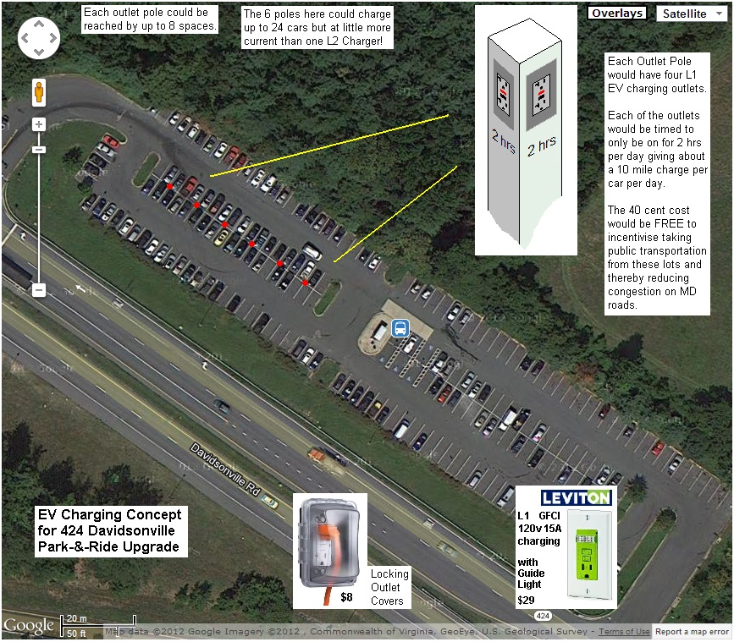

This placement shown above is of course representative, since the new outlets would actually be easier to install with the new additional 240 parking spaces being added in 2013.

Also, for simplicity of wiring, all four outlets on each post come on at the same 2 hour window and a simple Lamp on the top of the post indicates it is active. By running the 2 hour cycle on a 12 hour basis, then different shift workers can still be accommodated with their 2 hour opportunity while still only providing the limited 2 hour (40 cent) incentive per user. A car would have to remain parked over 14 hours to get two 40 cent charges. Hardly worth it, since the battery would be full after the first 2 hour charge anyway for the typical under 10 mile commuter to the lot.

The assumption that all cars in the lot will most likely need much less than a 10 mile charge (2 hours) is substantiated by the national DOT statistics that show that even 70% of full length commuters drive less than 16 miles to work. Assuming the bus ride from this lot is at least 6 miles, then, supports the 10 mile maximum estimate for the need for the charge and the value of this benefit. In otherwords, the risk of abuse associated with this 2 hour 40 cent free opportunity is extremely low.

Bob Bruninga, PE Bruninga@usna.edu | 410-293-6417
IEEE National Committee on Transportation and Aerospace Policy | EV Association of DC/MD

