Parking Lot EV Charging Option Guidelines Oct 2018

The EV Association of Maryland/DC
EVADC.org
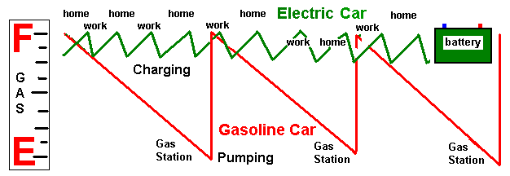

The value propositions to the owner of an EV are the cost of ownership and the convenience of overnight charging. In this respect, it is important to understand how the charging process for EV’s is a complete paradigm shift from our century legacy of the gas tank / public-gas-station model. A Battery is not a Tank:
Gas tanks are typically run-to-empty and then filled-to-full once a week at well distributed public gas stations. This is very different from the EV model shown here. EV’s are typically charged overnight at home and then wherever else is convenient away from home while parked.
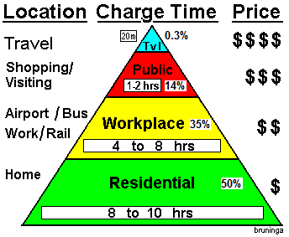
The gas vehicle must be driven to a public gas station periodically (while in use) to fill the gas tank in a few minutes while waiting. We think that is fast, but we overlook the inconvenience of having to make the trip to the gas station in the first place. With Electric vehicles, not only is there no gas pump, but more importantly, there is no need to go anywhere routinely to refuel in the first place. An EV can conveniently refuel from a charger or 120v outlet while parked. And since the typical commuter car spends more than 21 hours a day parked, usually at home or at work as shown in the Charging Pyramid, the act of refueling is nothing more than the few seconds to plug and unplug, the ultimate in convenience.
Guidance for the installation of EV charging stations: The promise of EV convenience is best met if the placement of the outlets or charger cords matches the location and demands of where EV’s are parked. Most EV charging takes place at home or at work. The Maryland Governors EV Infrastructure final report of 2012 concluded that over 97% of charging-at-work can be met with simple Level-1 charging at 120v and that public charging away from home will only be about 14% and the interstate cross-country need is much less than 1%. Considering these demographics, the following guidelines have evolved from years of experience by EV drivers in the EVADC.
- The charging time (L1 or L2) should match the parking spot usage (duration)
- More than half of all EV’s are PHEV’s and only need overnight to charge from 120v outlets
- Charging overnight or for several hours at work on L1 outlets requires no sharing of parking
- In 8 hour/daily parking at employer and transport stations, install 10-to-1 L1 vs L2 capabilities
- Place chargers in non-tempting parking locations where gas cars will not end up blocking access
- Place chargers out of the way to avoid EV animosity by gas drivers when the EV spaces are vacant
- Consider “EV’s only till 9AM” in lots that fill to full everyday by 9 AM to avoid EV animosity
- Place L2 chargers in short-term parking areas where car turnover is 1 or 2 hours or less
- Where sharing is not prohibited by law, put L2 chargers every 3rd space to allow for sharing
- Place L3 chargers along interstates and major arteries every 30 miles for EV travelers
- Avoid knee-jerk legislation trying to fix the above problems by forcing unnatural human behavior

Improper placement of chargers leads to low efficiency of use and secondary issues of antagonism between gas and EV drivers. Then, knee-jerk legislation attempts to correct human behavior around these obstacles which could have been avoided with proper placement in the first place.

