Get R.E.A.L: Road Equity Adjustment Legislation

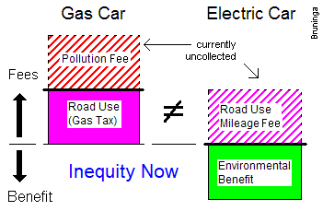
Bob Bruninga, PE bruninga@usna.edu
http://aprs.org/EV-and-gas-taxes.html

The Maryland EV Infrastructure plan will need to consider the long term impact of EVs on road use and maintenance. Currently road maintenance is funded by the Gas Tax. In the future, MDOT will eventually need to consider an alternative contribution method for EVs.

There are Inequities with respect to the roads between EV’s and Fossil fueled vehicles now. EVs provide a great benefit to our air, while fossil fuel cars add wear-and-tear on the environment. For visualization, this chart shows usage/consumption above the line and benefits below. Current impacts are shown solid, and future fees are hashed.

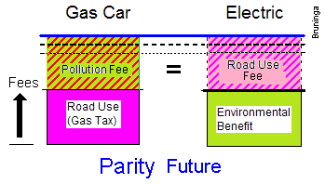
As shown, both fossil fuel vehicles and EVs have a usage impact on the roads. Gas cars pay a gas tax for the roads but their huge cost in environmental damage is not being collected. Conversely, EV road fees are not currently being collected but EV environ-mental benefits are real. The pollution cost of the fossil fuel vehicles adds to their usage impact, whereas, the environmental benefits of the EVs shown in green tend to balance out their road load for a net-0 overall cost now. This apparent free ride for a few EVs is accepted now because of their significant benefit in reducing pollution. Considering environmental impacts and road usage costs, then, we need to adjust the vehicle fees for a degree of parity between gas and EVs today.

But, as we consider raising usage fees on EVs, to be fair, we need to also raise the pollution fee on fossil fueled vehicles as shown here. To maintain parity in the future, the hashed colors need to be paid by both vehicles. As we raise the road fee on the EVs, there must be a comparable and equal rise in the pollution fee on fossil fueled vehicles.

The mechanism for collecting these fees is probably at the MVA. This new usage fee is the same across all vehicles inversely proportional to their MPG or MPGe since those energy measures are comparable to their load on the roads. Those fees from EVs should go to roads and those added fees from fossil fuel vehicles should go towards renewable energy and the environment. The gas tax would continue to go exclusively towards roads and transportation. -|-

